ADAMSON UNIVERSITY
COLLEGE OF COMPUTING AND INFORMATION TECHNOLOGY
COMPUTER SCIENCE DEPARTMENT

ACADEMIC SERVICE LEARNING
DATA MANAGEMENT SYSTEM

2ND SEMESTER, S.Y 2024 - 2025



IN COOPERATION WITH
DEMPA PUBLICATIONS INC.
MAKATI, METRO MANILA

Submitted by:
Caacbay, Miguel John
Magkasi, Sophia Bianca
Montañez, Samantha Ashley
Ventura, James Christian
Yabut, Aleerah Marishka

INFORMATION MANAGEMENT LAB
Section: 25030

Prof. Jay Alonzo Abaleta
ASL Instructor

MAY 2025

ACKNOWLEDGEMENT

This project would have not been possible without the contributions of the following individuals and institutions:

The researchers express their deepest gratitude to Adamson University for giving permission to the researchers to reach out and assist Dempa Publications Inc. with their system through its Academic Service Learning (ASL) program. This experience has given the researchers an advantage in the professional setting that aligns in their field.

The researchers would also like to extend this to the Computer Science (C.S) Department for this opportunity, giving advice and guidance, and their support for the researchers. Making the researchers interact with others in a professional manner and contribute to a company by aiding to the needs of the organization.

The researchers also express their appreciation to Dempa Publications Inc. and Sir Christian Canoza, with their cooperation and active participation, this has played a major role for the researchers to understand the company’s data management system and needs.

Lastly, to the researchers’ professor, Sir Jay Abaleta, whose continuous support and advice have been tremendously helpful throughout this ASL research journey.

This research has been a journey, each moment filled with learning and fun, with late-nights work and laughter. The researchers once more are offering their deepest gratitudes to Adamson University, C.S Department, Dempa Publications Inc., Sir Christian Canoza, and Sir Jay Abaleta for their support, for this opportunity, and their guidance.

TABLE OF CONTENTS

ACKNOWLEDGEMENT 2
CHAPTER 1: INTRODUCTION 4
1.1.1 History 4
1.1.2 Vision and Mission 5
1.3 Organizational Structure 6
1.4 Statement of the Problem 7
1.5 Objectives of the Study 8
1.6 Scope and Limitations 8
CHAPTER 2: DATABASE & PROGRAM STRUCTURE 10
2.1 Program Flowchart 10
2.2 Entity Relationship Notation 12
2.3 Entity Relationship Diagram 13
2.4 User Interface 14
CHAPTER 3: The Forms 21
3.1 ASL Plan of Activities 21
3.2 College Dean Report 22
3.3 Faculty Member Report Form 23
3.4 Faculty Member Evaluation Form 24
3.5 Student Registration Form 25
3.6 Class Evaluation Form 30
3.7 Student Evaluation Form 31
3.8 Community / Organization Evaluation Form 36
CHAPTER 4: REFLECTION 41
5.1 Dempa Publications Inc. - Philippines 46
5.2 Visit to the Organization (DEMPA Publications Philippines Office) 47
5.3 Program Development 48
5.4 ASL Presentation 49
5.5 Deployment 50

CHAPTER 1: INTRODUCTION

1.1.1 History
With an initial capital of ¥93.31 million, Dempa Publications, Inc. was founded on May 5, 1950 at a time when the electronics industry in Japan was still at the early stage of development. Dempa Publications was one of the pioneer media companies that covered and served the various facets of the electronics industry and related fields through Dempa Shimbun, which made its maiden issue in January 1951, initially, as a monthly newspaper.

Since then, Dempa Publications opened its doors to a host of multilingual publications that served professionals not just of the electronics and semiconductor industries, but also of information technology, consumer and home electronics, among many others. Among its notable publications that have been published and made mark in the international scene include Journal of Electronics Industry (1972); Office Equipment and Products (1972); Audio Video International (AVI) magazine (1972); Microcontroller BASIC magazine (1987); OA PC magazine (1988), among others.
Dempa Publications’ prominence as a leading business-to-business trade publications in Japan extended overseas when it opened several international offices and affiliate companies in New York in United States, Dusseldorf in Germany, Kuala Lumpur in Malaysia, Hong Kong Special Administrative Region of the People’s Republic of China (Hong Kong SAR), Seoul in Korea, Taipei in Taiwan, and Manila in Philippines.
For over 60 years now, Dempa Shimbun Daily remains as Dempa Publications’ flagship Japanese trade newspaper. Circulated largely in Japan, it has more or less 300,000 subscribers and a pass-around rate of 5.2 readers per issue. It provides timely information to professionals, covering the most vital sectors and areas of the electronics industry, such as information technology, communications, semiconductors and devices, electronic components and materials, home electronic and electrical appliances, consumer electronics, factory automation and measuring instruments, as well as electronics retailing.
Dempa Publications also publishes Asia Electronics Industry (AEI), a monthly English magazine that got its start in October 1996. AEI has been providing up-to-date information to industry professionals in the fields of semiconductor, components and devices, test and measuring, and other related fields across China, Korea, Taiwan, Singapore, Malaysia, Philippines, Hong Kong, India, Thailand, Indonesia and other Asian countries.
Broadcasting Equipment and Technology (BET) is published in time for the broadcast industry’s major trade events, namely the National Association of Broadcasters (NAB) Show in Las Vegas, Nevada in April, and the International Broadcasting Convention (IBC) Show in Amsterdam, The Netherlands. A Chinese edition of BET is also published for distribution to the Beijing International Radio, TV & Film Equipment (BIRTV) Expo.
Dempa Publications is headquartered in Tokyo, Japan. It presently maintains a branch office in Osaka, as well as satellite offices in Fukuoka, Sendai, Nagoya, and Hiroshima across Japan. Overseas, Dempa Publications has branch offices in Seoul, Korea and Manila, Philippines, as well as a sales office in Taipei, Taiwan.

1.1.2 Vision and Mission

VISION
The future that Dempa Publication wants to implement:
- Supporting the manufacturing society with unique ideas and enriching the
world together with you

MISSION
What Dempa Publications must responsibly do to implement its vision:
- Always take on new challenges and continue to provide unique
information, products, and services that connect the world.

1.3 Organizational Structure
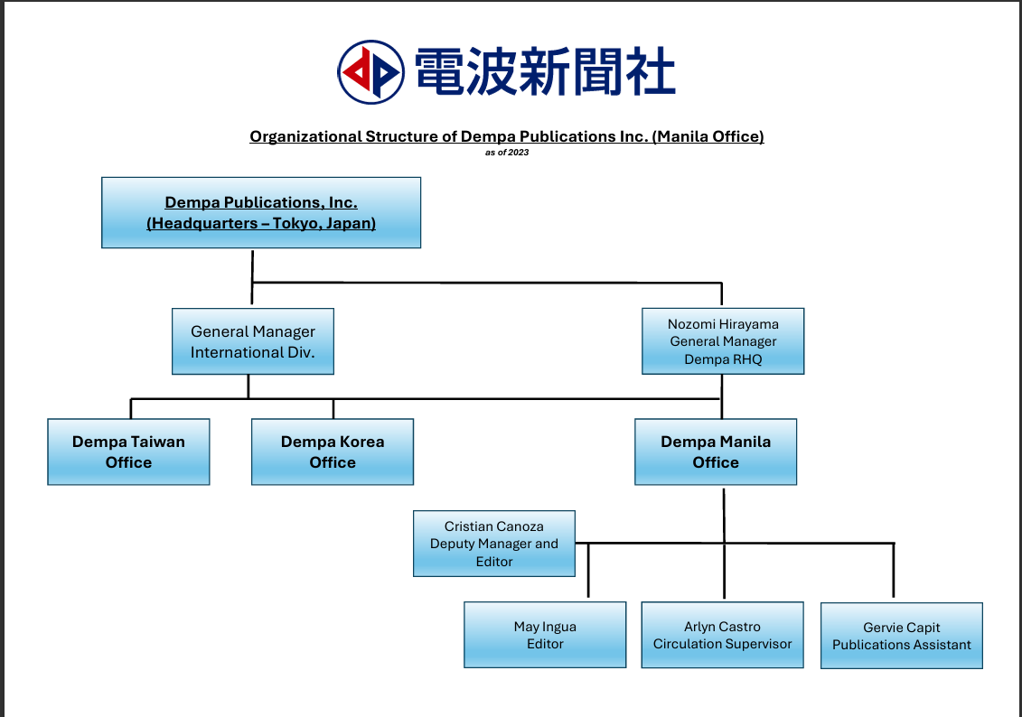

1.4 Statement of the Problem
Dempa Publications Inc. is currently facing a problem with its data management. With over 40,000 subscriptions, the lack of organization and categorization can lead to difficulties, such as distinguishing between its active and inactive subscribers. Leading to inefficiencies and inaccurate reporting. Additionally, the database contains multiple tables with the same column structures, but the data represents different countries. Increasing the need for storage makes data retrieval and maintenance difficult. The following are the limitations that come with maintaining this system:

- Inaccuracies - With active and dormant subscribers mixed up, preventing the company from having accurate tracking of their customers.
- Redundancy and Inefficiency - Databases having multiple tables with the same column but different country sources increases the need for storage and hence slower retrieval and complicating data maintenance.
- Monitoring Difficulty - Extraction from a disorganized database leads to inaccurate reports and analysis, impacting and delaying the business decision making process.
- Scalability - As their subscriptions grow, the spreadsheet-based approach struggles to accommodate these records, highlighting its inefficiencies and making it harder to manage and scale their operations smoothly.

With these difficulties, the shift from spreadsheets to a more manageable database management system is advisable. Creating a database suited to solve their problems will increase its efficiency, providing an easier management for Dempa Publications Inc. and improving customer engagement.

1.5 Objectives of the Study

- To facilitate and provide regular updates regarding the necessary data.
- To redesign the data structure; eliminating the multiple tables with the same columns with the aim of making them more manageable.
- To provide a more intuitive and comprehensible system for the employees. Greatly reducing the risks of errors, if not, fully eliminate it.
- To ensure the security of gathered data. Provided that these are the clients’ personal information.
- To ensure data back-ups as well as recovery that would prevent the loss of data necessary for the company.

1.6 Scope and Limitations
This study focuses on reorganizing and improving data management by developing a system that automates data entry, enhances the input record organization, and modifies the customer’s tracking subscription. However, it is essential to recognize that this study has some areas of certain limitations.

SCOPE

- The system integrated the CRUD framework which allows the user to create, read, update, and delete records efficiently to ensure the data’s accuracy, well-organized, reduce the error and redundancy of information.
- An admin login feature gives administrators full control of the system allowing them to manage user access, adjust settings, and oversee data operation for smooth and secure data management.

- The Employee has their own login access, ensuring to manage and update subscriber information to secure and efficient handling of data within its authorization role and access control.
- It has a dashboard feature to show the site visits, track new subscribers over the past week or month, and present charts that break down subscriber information by country, city, or state.
- There would be a generated report about the data it has gathered.

LIMITATIONS

- For privacy and security purposes, we will not have full access to the client’s data; this means that sensitive information will remain under the client’s control to protect its confidentiality.

CHAPTER 2: DATABASE & PROGRAM STRUCTURE

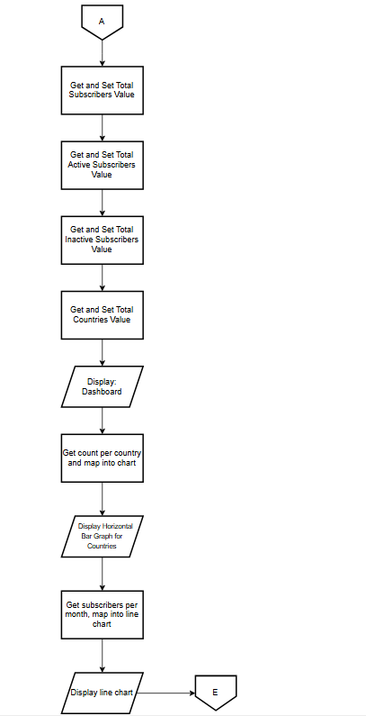
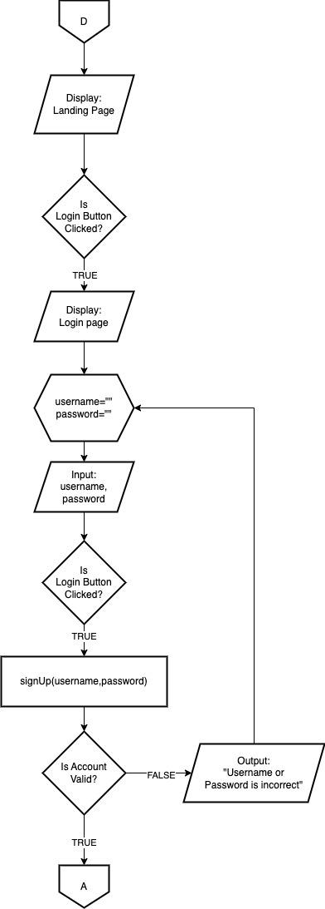
2.1 Program Flowchart

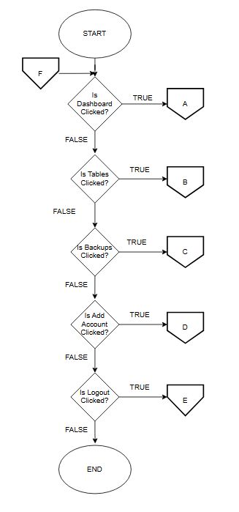
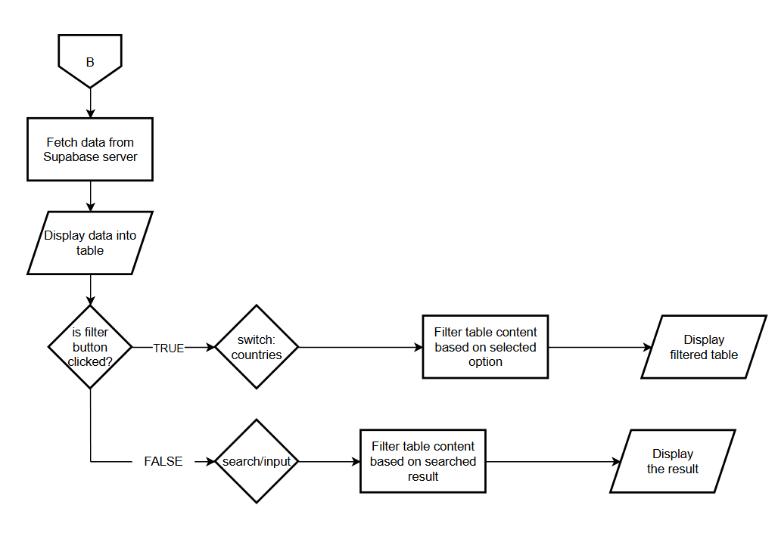

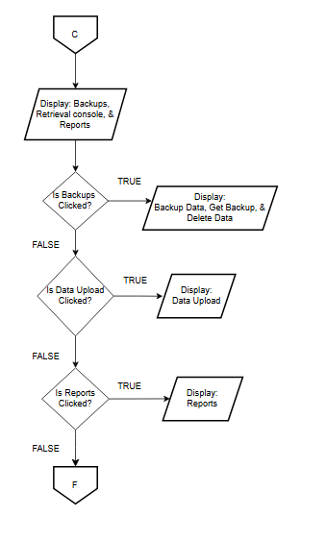

2.2 Entity Relationship Notation

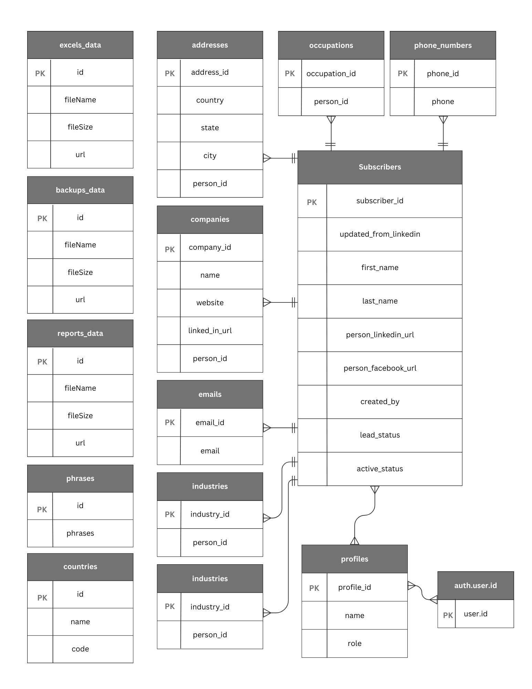

2.3 Entity Relationship Diagram
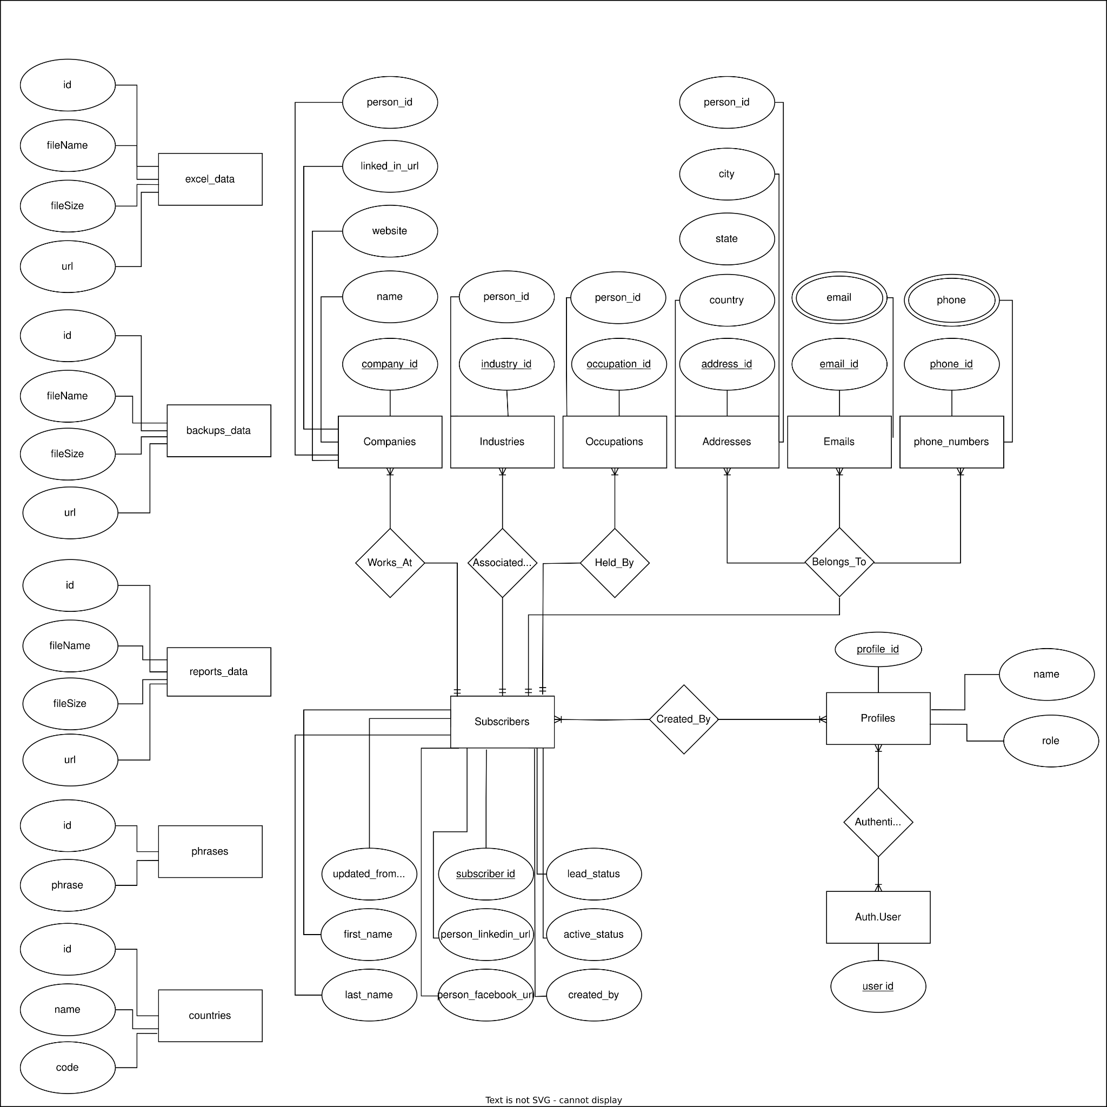

2.4 User Interface
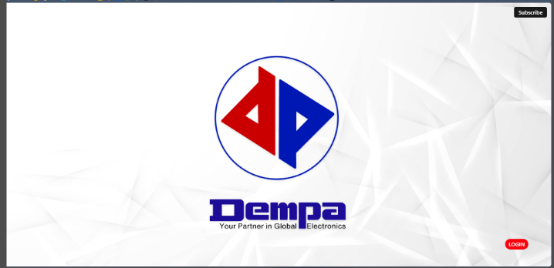
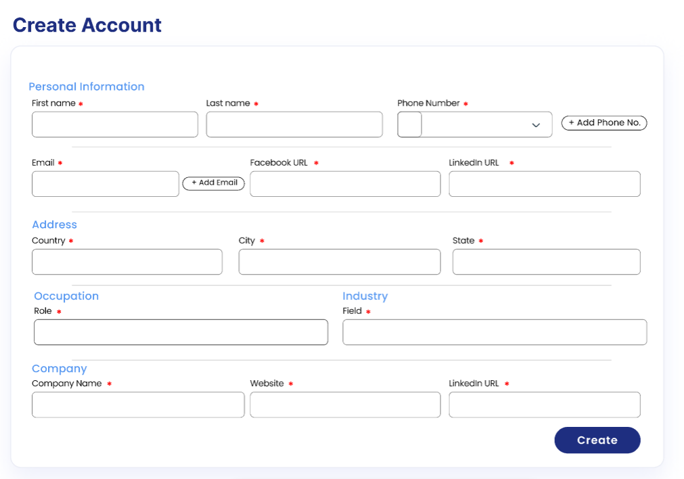
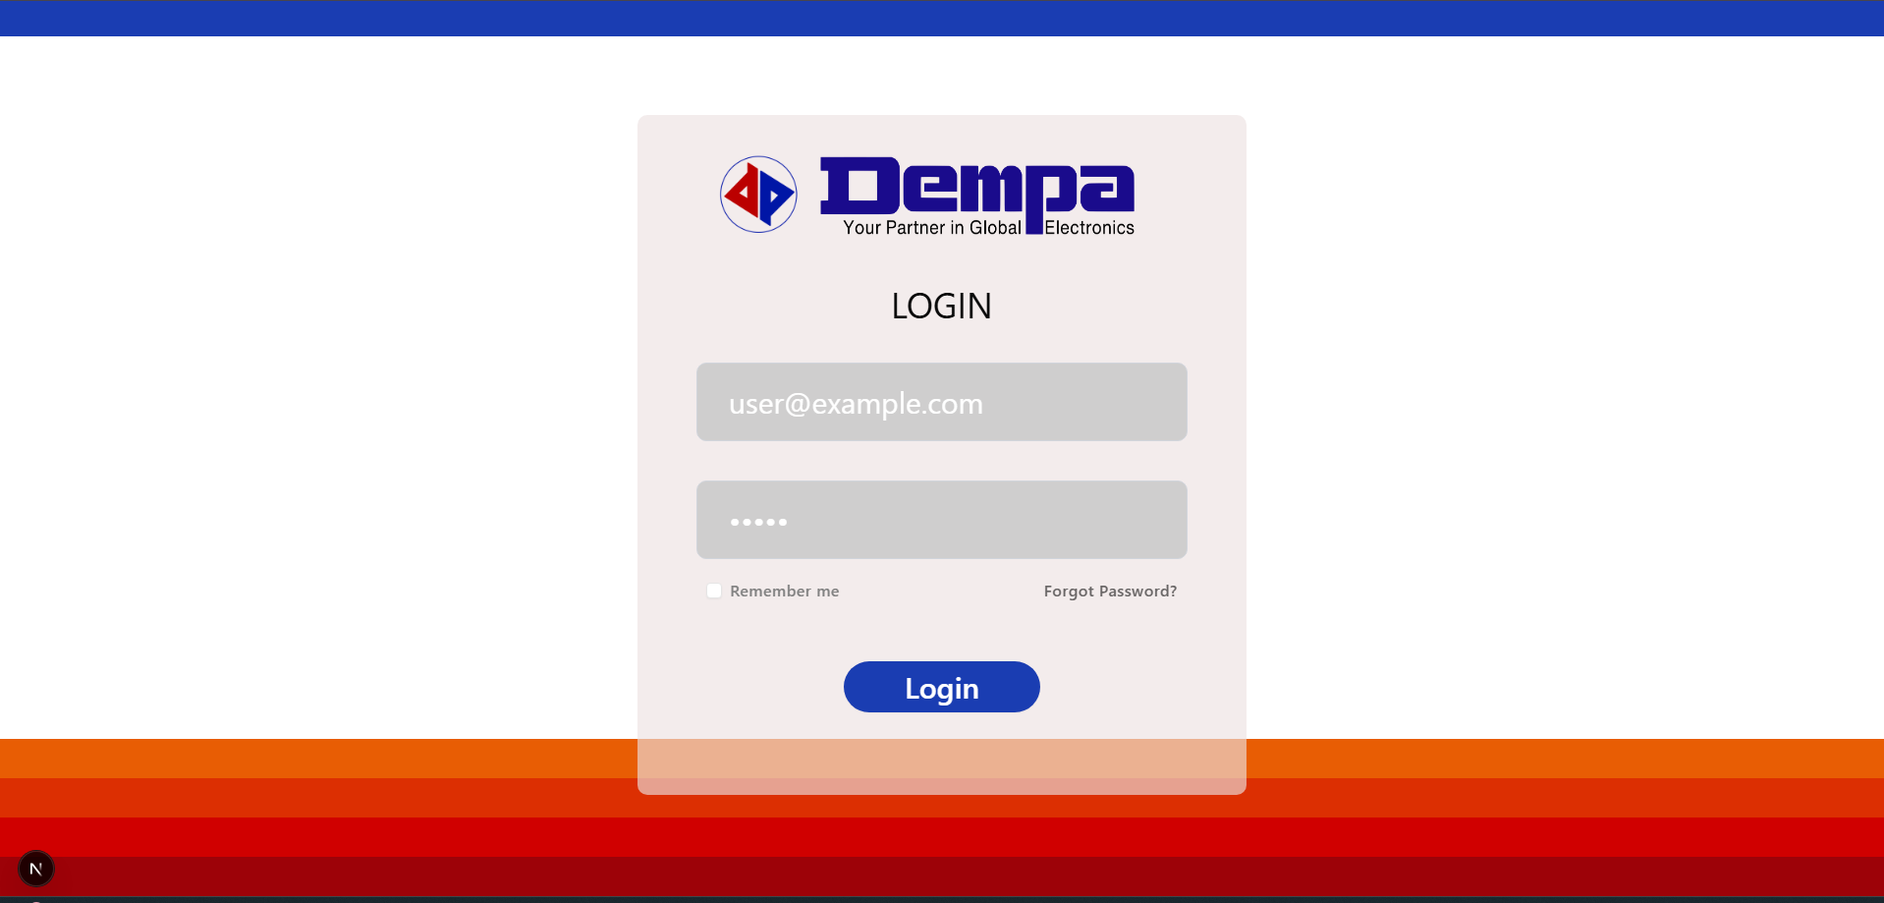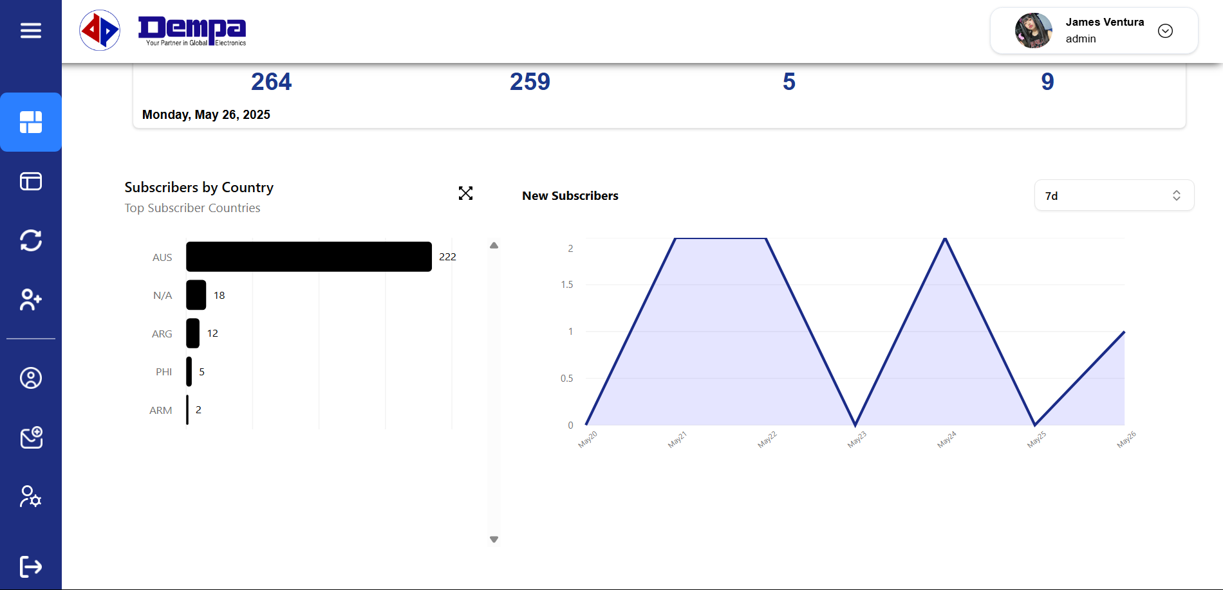
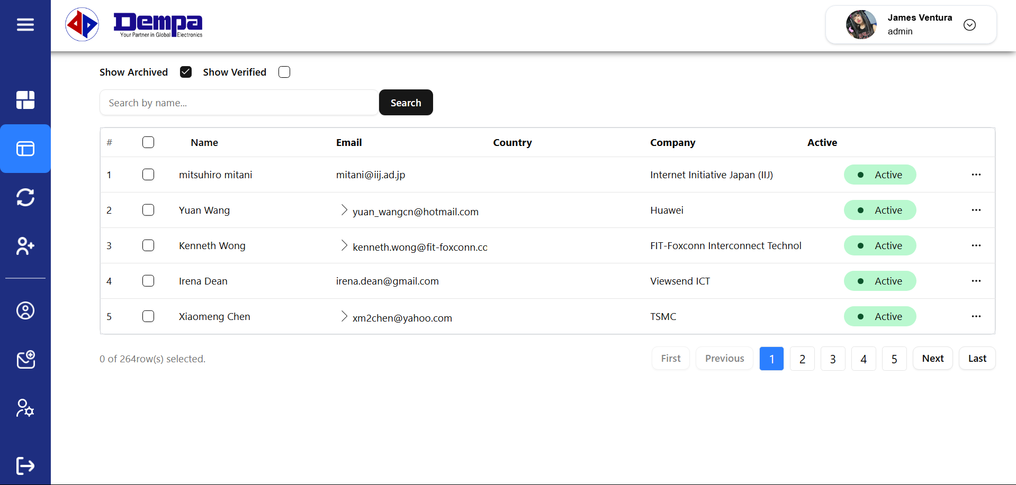

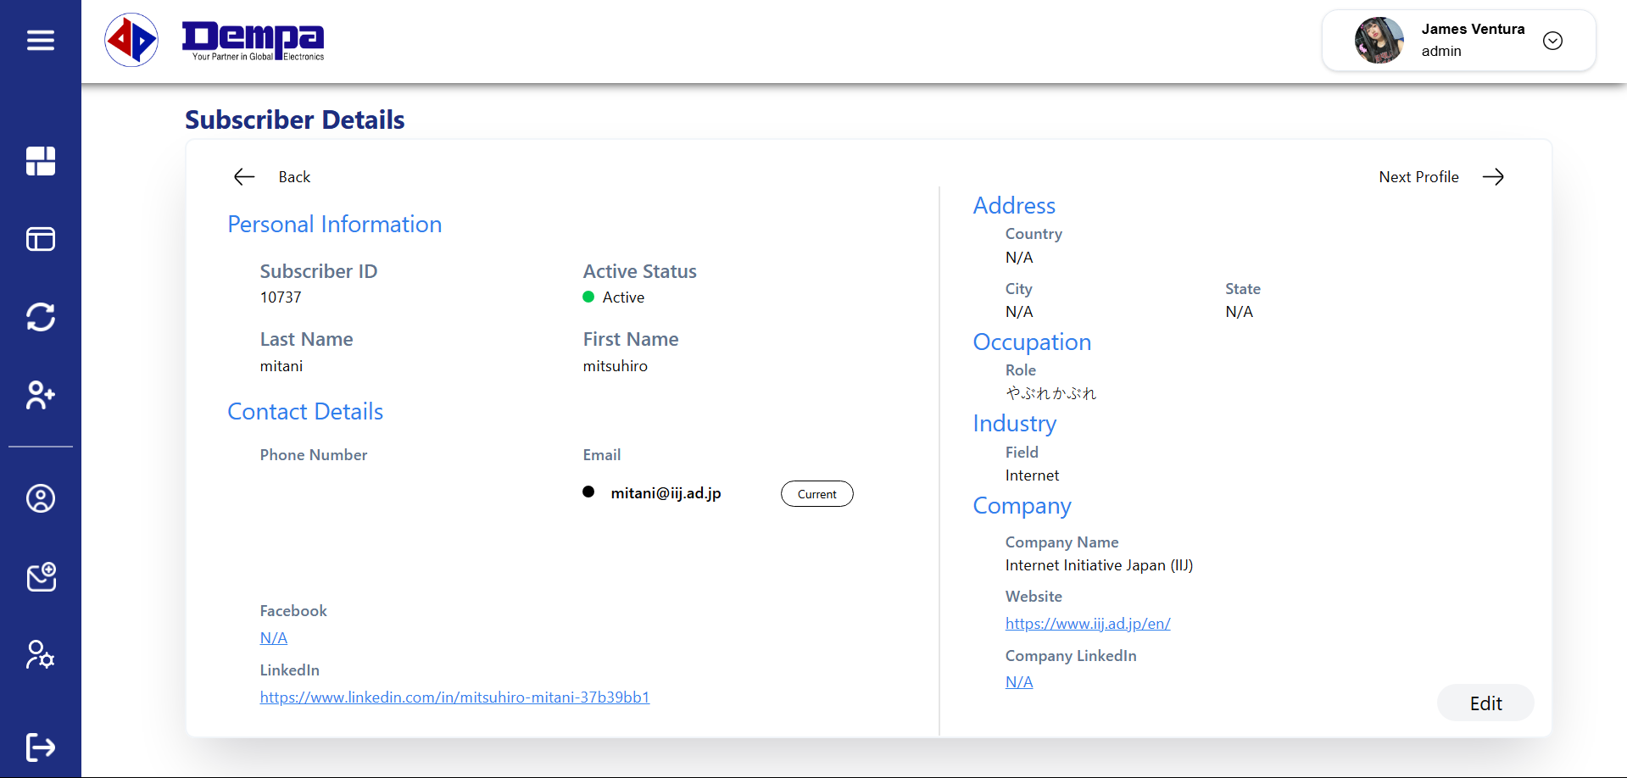
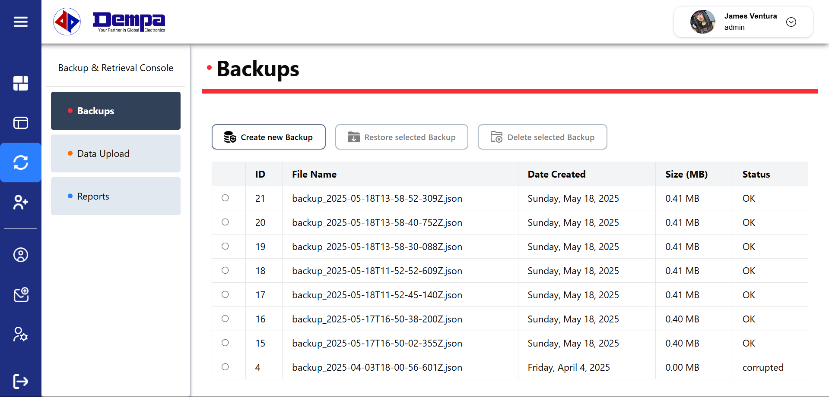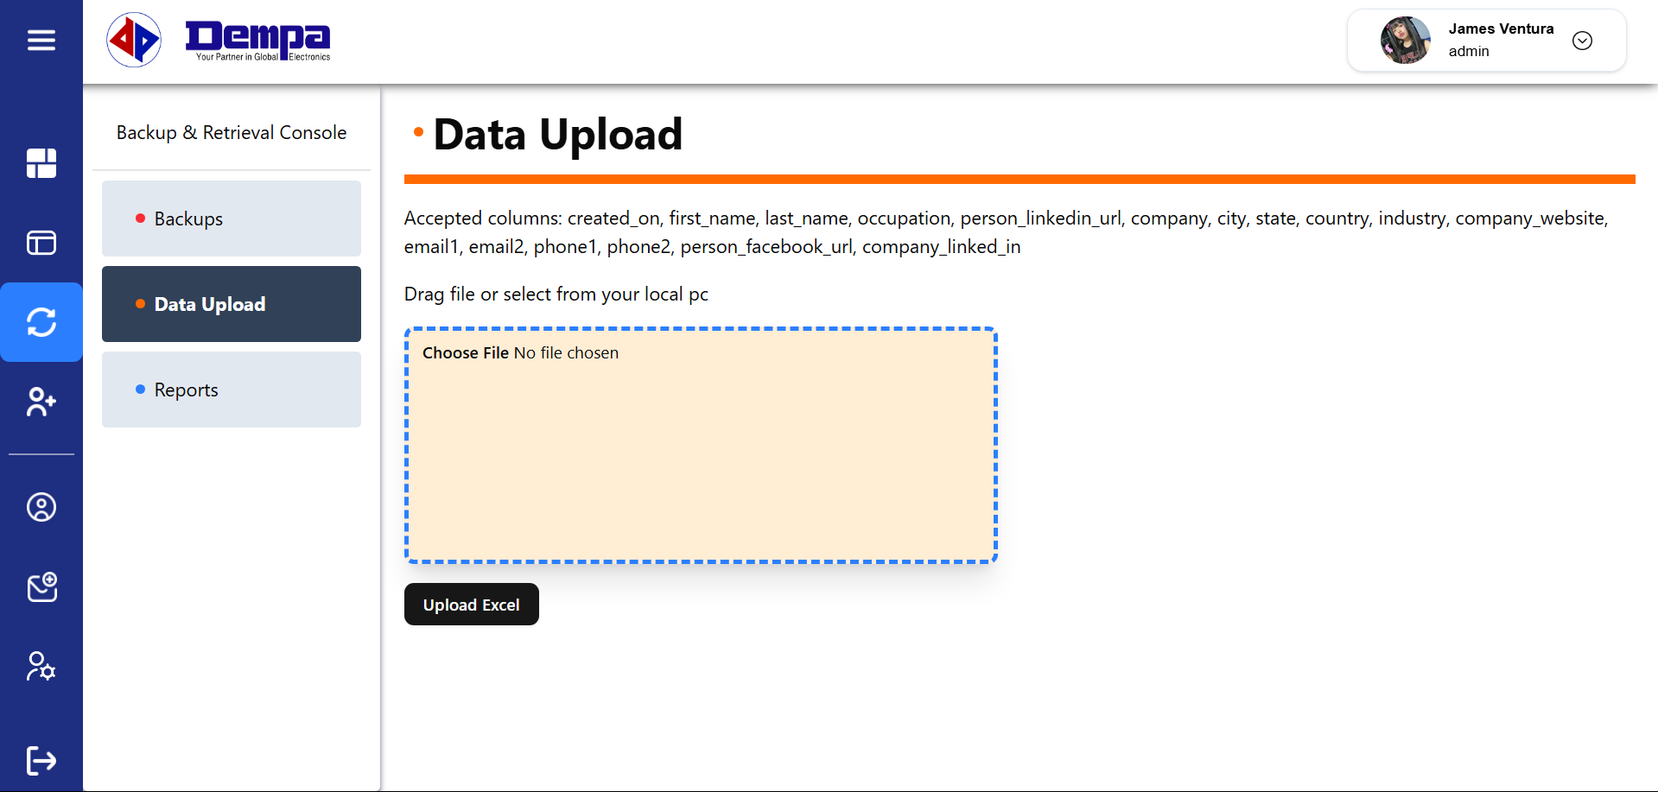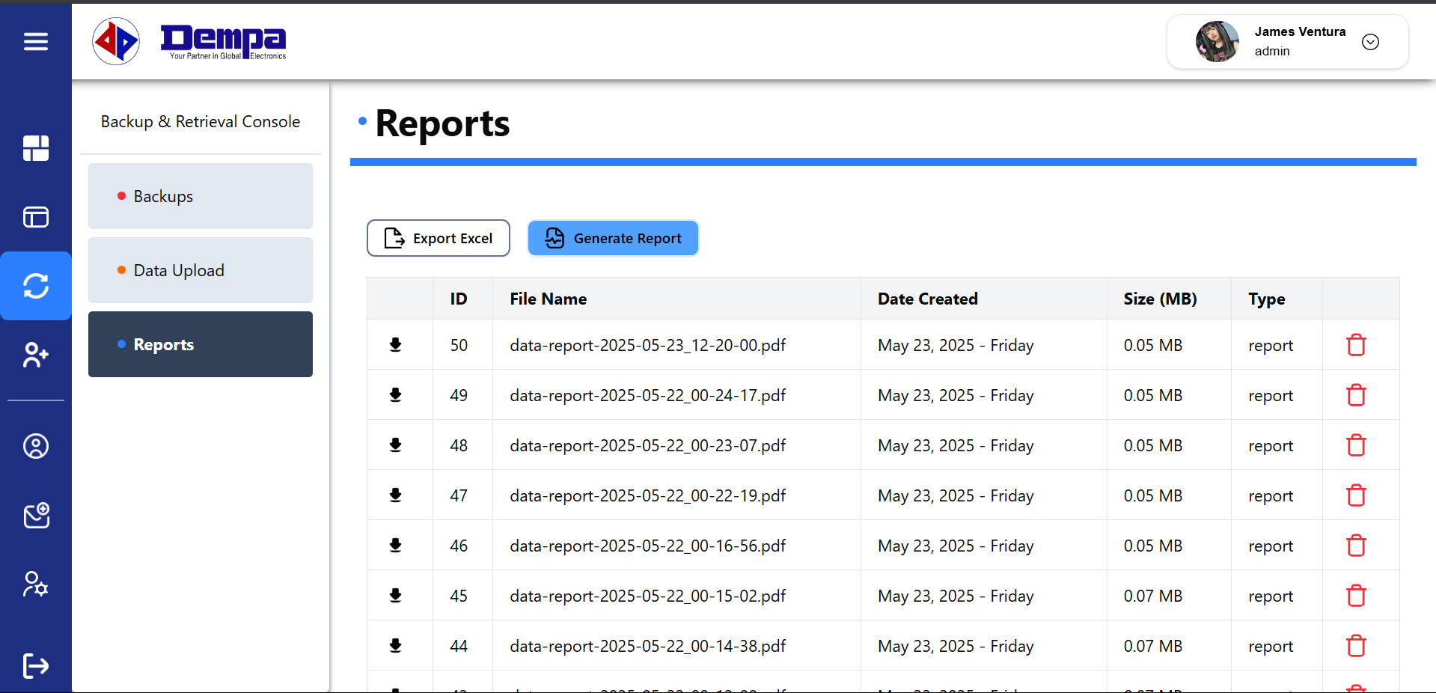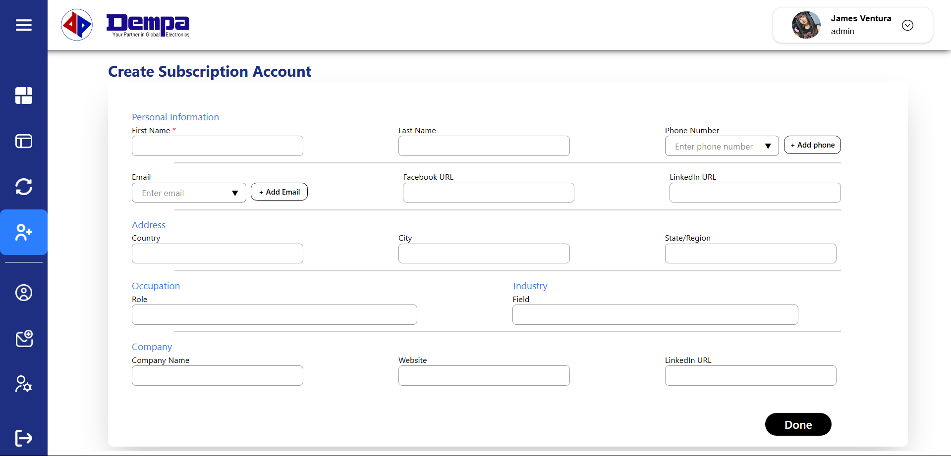
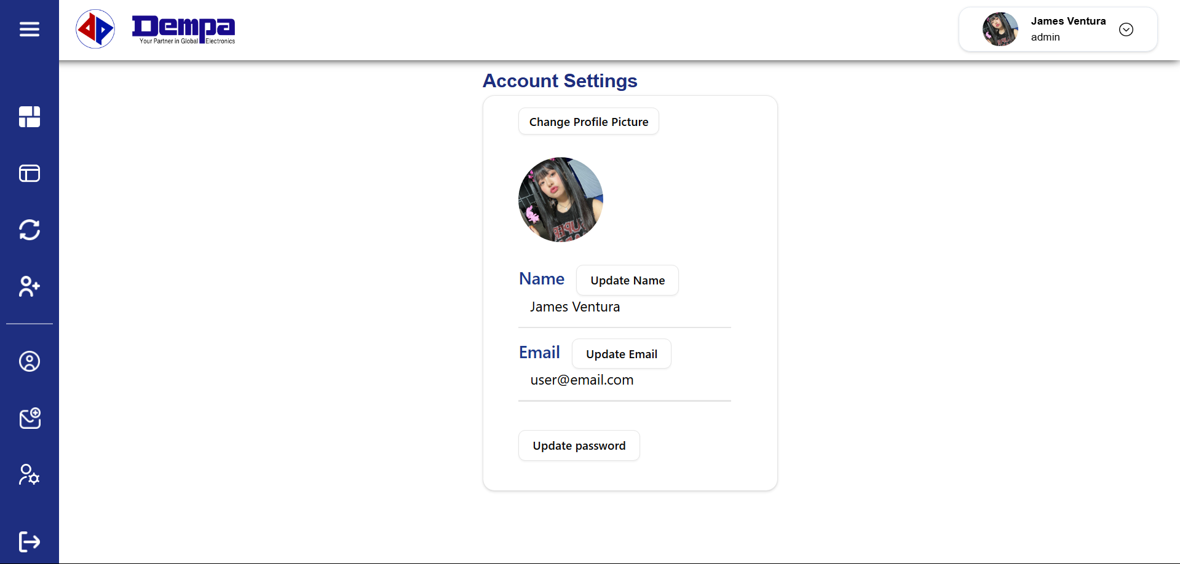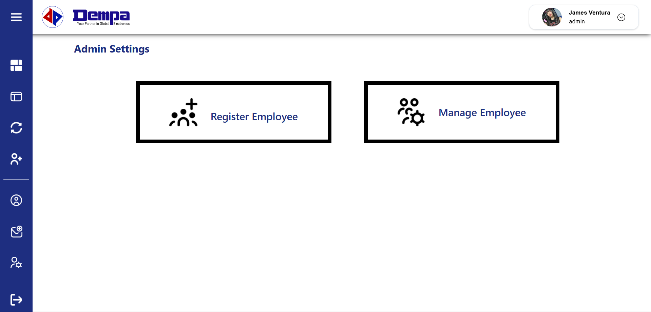

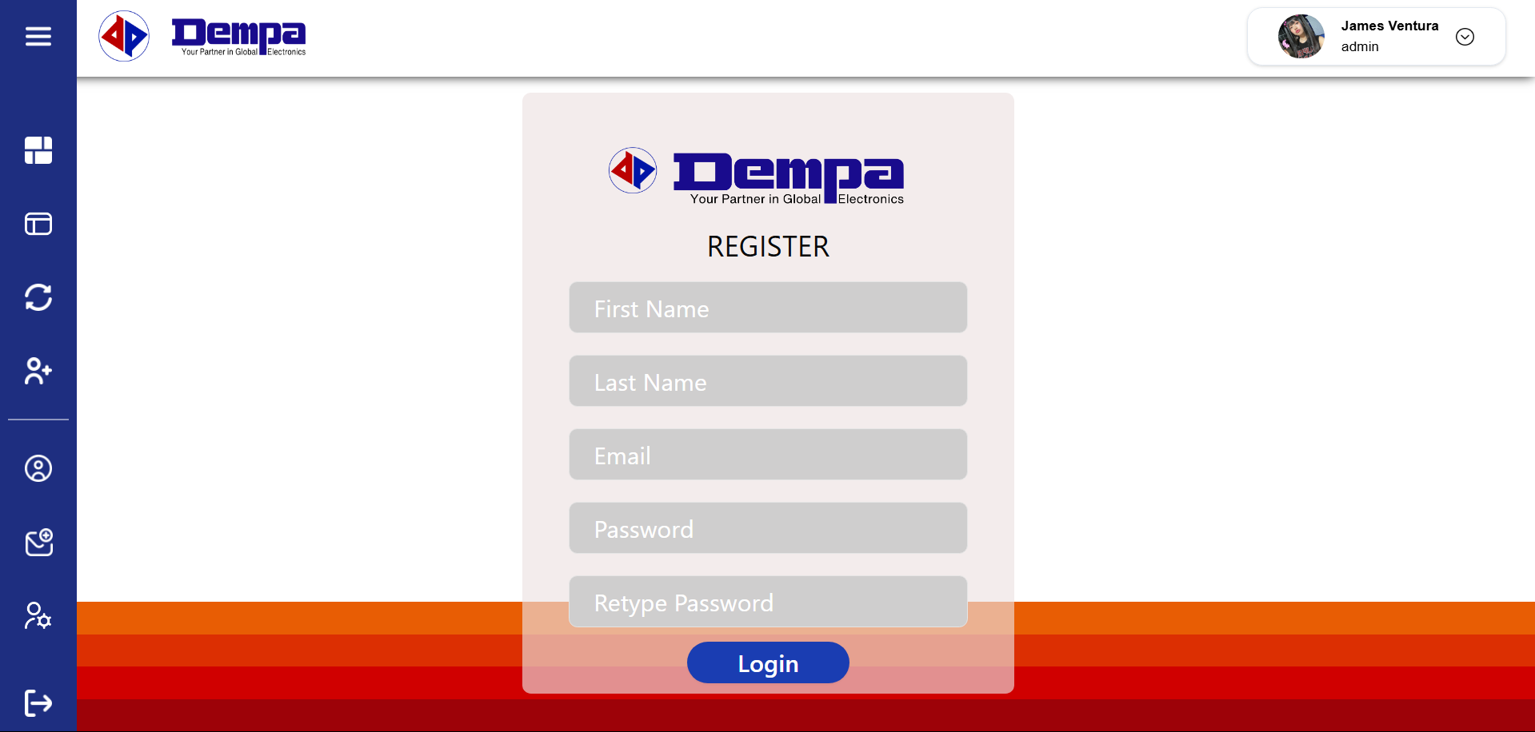

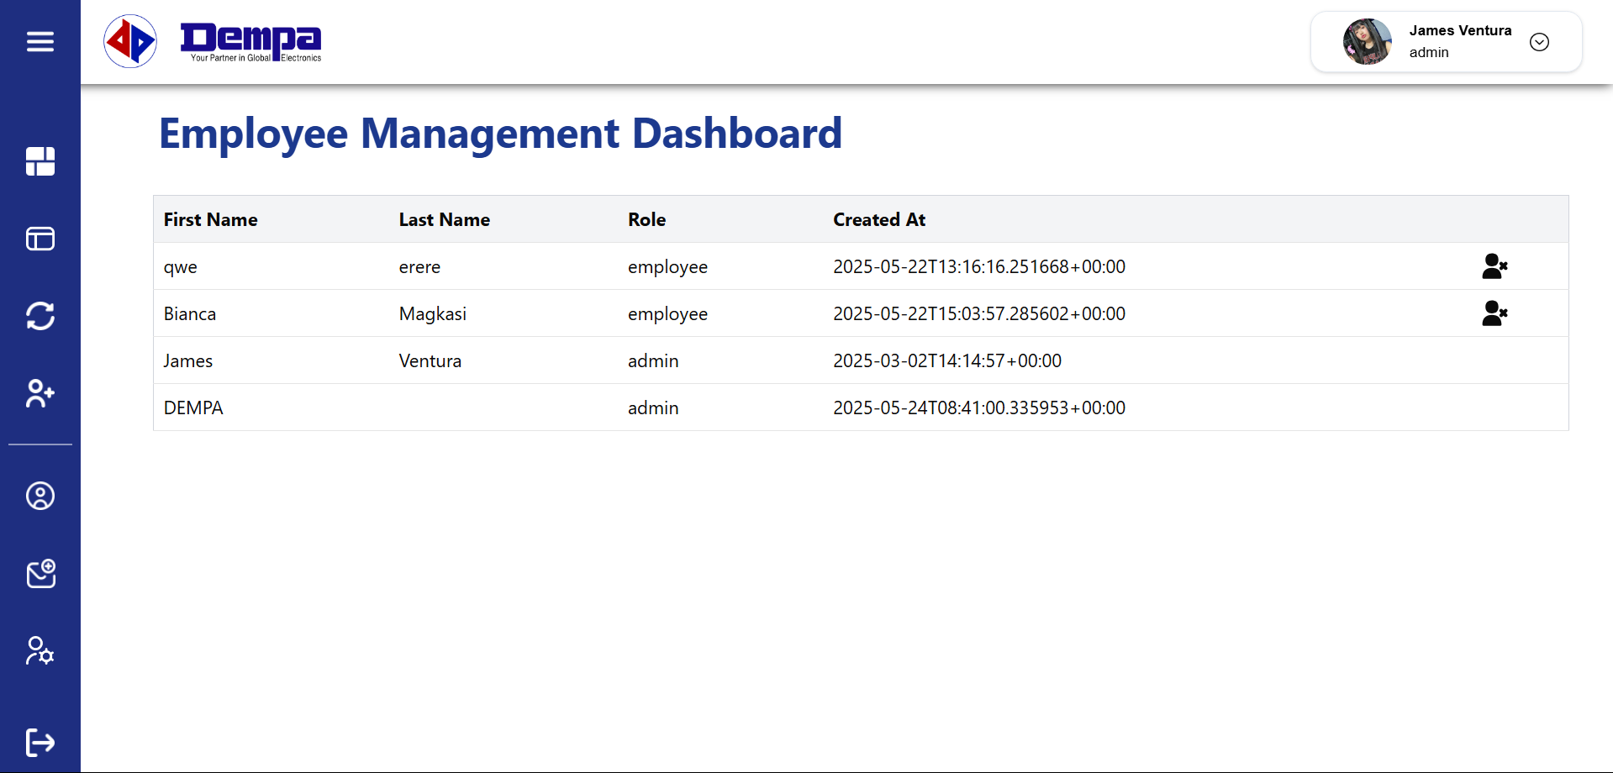

CHAPTER 3: The Forms

3.1 ASL Plan of Activities
ADAMSON UNIVERSITY
ACADEMIC SERVICE LEARNING (ASL)
ASL ACTIVITY PLAN

Subject: Information Management
Topic: Publication Subscribers Management and Analytics
Objectives: To develop a web-based application that can facilitate data entry and filtration, as well as search, retrieve, and update subscriber information all while providing statistical insights derived from the database.
Activities:
- Project Planning/Preparation
- Signing of Letter of Intent
- Completion of Activity Form
- Completion of Consent and Release forms for off-campus activity
- Informal Interview

- Data Gathering
Task: To conduct an interview with Dempa Publications – Philippines in order to understand the challenges they face in managing their data as well as identify potential features to add to the system to help enhance their work efficiency, and finally to collect all required data and information needed for our software project and documentation.
- What does Dempa Publications do?
- Can you tell us about the history of Dempa Publications?
- What is its mission and vision?
- What is the organizational structure of Dempa Publications?
- What data does your company manage?
- How are you currently collecting, storing and managing your data?
- What are the challenges you face with this method?
- Can we ask for sample data?

- Pre-development
- Create a high-fidelity user interface design for the application in Figma to visualize the final product.
- Create a flowchart of the processes within the system.
- Create an entity relationship diagram and notation to plan out the relationships of data entities.

- Development
- Build the front-end code using NextJS, Tailwind, and Typescript.
- Develop the back-end code with expressJ, NodeJS, and Supabase.

- Testing
- Test and check for bugs and inconsistencies to fix the defects in the system.

- Deployment
- Deploy the application in Vercel.
- Launch the web application to the company’s system.
- Provide a user manual to the company for its effectiveness of the system.

3.2 College Dean Report
ADAMSON UNIVERSITY
ACADEMIC SERVICE LEARNING (ASL)
College Dean Report
College of Computing and Information Technology
College: School Year: 2024-2025
Semester: 2nd Semester Date:
Course / Subject Participating in ASL | Total No. of Students Enrolled | Total No. of Students Participating in ASL | Name of Community / Organization Served | Total Hours Served

SUMMARY
Course / Subject Participating in ASL | Total No. of Students Enrolled | Total No. of Students Participating in ASL | Name of Community / Organization Served | Total Hours Served

3.3 Faculty Member Report Form
ADAMSON UNIVERSITY
ACADEMIC SERVICE LEARNING (ASL)
Faculty Member Report Form
Course / Subject Participating in ASL | Total No. of Students Enrolled | Total No. of Students Participating in ASL | Name of Community / Organization Served | Total Hours Served

SUMMARY
Course / Subject Participating in ASL | Total No. of Students Enrolled | Total No. of Students Participating in ASL | Name of Community / Organization Served | Total Hours Served

3.4 Faculty Member Evaluation Form
2024 - 2025
2nd Semester

Mr. Jay Abaleta
Semester: _______________ School Year: _______________
Dempa Publications Inc. - Philippines
Name of Professor: _______________
Name of Community / Organization Served: _______________________________________

Please rate the class in the following manner:

1 = Poor 2 = Fair 3 = Good 4 = Very Good 5 = Outstanding

- Attendance / Punctuality | 1 | 2 | 3 | 4 | 5
- Dependability | 1 | 2 | 3 | 4 | 5
- Participation / Involvement | 1 | 2 | 3 | 4 | 5
- Skills / Quality of Work | 1 | 2 | 3 | 4 | 5
- Overall Performance | 1 | 2 | 3 | 4 | 5

Question: How did the student’s project help you and your community?

Answer:___________________________________________________________________________________________________________________________________________________________________________________________________________________________________________________________________________________________________________________________________________________________________________________________________________________________________________________________________________________________________________________________________________________________________________________________________________

Name of Evaluator: _______________________________________________________________

Signature: _________________________________

Date: __________________

3.5 Student Registration Form
ADAMSON UNIVERSITY
ACADEMIC SERVICE LEARNING (ASL)
Registration Information
NAME OF STUDENT
Caacbay, Miguel John Cipriano

____________________ ____________________ ____________________
Surname Given Name Middle Name
BSCS - 2nd Year
09981728548
202216238
Brgy. DonBosco Paranaque City

Student No. : __________________ Course & Year : __________________
Permanent Address : __________________ Tel. CP No. : __________________

ACADEMIC INFORMATION

25030
10:30-1:30
2nd Semester
Sir Jay Abaleta
Information Management
Friday
CL2
2024-2025
Subject w/ ASL: __________________ Section: __________________
Day: __________________ Time: __________________
Room: __________________ Semester: __________________
School Year: __________________ Professor: __________________

ASL SELECTED COMMUNITY / ORGANIZATION INFORMATION
Dempa Publications Inc.
Salcedo Village, 98 V.A. Rufino St, Makati, Metro Manila
Mr. Cristian Canoza
+632-53105428

Name of Community / Organization : _______________________________________
Address : _______________________________________
Contact Person : _______________________________________
Contact No. : _______________________________________

ADAMSON UNIVERSITY
ACADEMIC SERVICE LEARNING (ASL)
Registration Information
NAME OF STUDENT
Magkasi Sophia Bianca Jimenez

____________________ ____________________ ____________________
Surname Given Name Middle Name
202314179 BSCS - 2nd Year
Novaliches, Quezon City 0908 695 0018
Student No. : __________________ Course & Year : __________________
Permanent Address : __________________ Tel. CP No. : __________________

ACADEMIC INFORMATION
Information Management 25030
Friday 10:30 AM - 1:30 PM
CL 2 2nd Semester
2024 - 2025 Jay Abaleta

Subject w/ ASL: __________________ Section: __________________
Day: __________________ Time: __________________
Room: __________________ Semester: __________________
School Year: __________________ Professor: __________________

ASL SELECTED COMMUNITY / ORGANIZATION INFORMATION
Dempa Publications Inc.
Salcedo Village, 98 V.A. Rufino St, Makati, Metro Manila
Mr. Cristian Canoza
+632-53105428

Name of Community / Organization : _______________________________________
Address : _______________________________________
Contact Person : _______________________________________
Contact No. : _______________________________________

ADAMSON UNIVERSITY
ACADEMIC SERVICE LEARNING (ASL)
Registration Information
NAME OF STUDENT
Montañez Samantha Ashley Dulay

____________________ ____________________ ____________________
Surname Given Name Middle Name
202413774 BSCS - 2nd Year
West Rembo, Taguig 09664533937
Student No. : __________________ Course & Year : __________________
Permanent Address : __________________ Tel. CP No. : __________________

ACADEMIC INFORMATION
Information Management 25030
Friday 10:30 AM - 1:30 PM
CL 2 2nd Semester
2024 - 2025 Jay Abaleta
Subject w/ ASL: __________________ Section: __________________
Day: __________________ Time: __________________
Room: __________________ Semester: __________________
School Year: __________________ Professor: __________________

ASL SELECTED COMMUNITY / ORGANIZATION INFORMATION
Dempa Publications Inc.
Salcedo Village, 98 V.A. Rufino St, Makati, Metro Manila
Mr. Cristian Canoza
+632-53105428

Name of Community / Organization : _______________________________________
Address : _______________________________________
Contact Person : _______________________________________
Contact No. : _______________________________________

ADAMSON UNIVERSITY
ACADEMIC SERVICE LEARNING (ASL)
Registration Information
NAME OF STUDENT
Ventura James Christian Borado

____________________ ____________________ ____________________
Surname Given Name Middle Name
202314179 BSCS - 2nd Year
Masambong, Quezon City 0976 496 8152
Student No. : __________________ Course & Year : __________________
Permanent Address : __________________ Tel. CP No. : __________________

ACADEMIC INFORMATION
Information Management 25030
Friday 10:30 AM - 1:30 PM
CL 2 2nd Semester
2024 - 2025 Jay Abaleta
Subject w/ ASL: __________________ Section: __________________
Day: __________________ Time: __________________
Room: __________________ Semester: __________________
School Year: __________________ Professor: __________________

ASL SELECTED COMMUNITY / ORGANIZATION INFORMATION
Dempa Publications Inc.
Salcedo Village, 98 V.A. Rufino St, Makati, Metro Manila
Mr. Cristian Canoza
+632-53105428

Name of Community / Organization : _______________________________________
Address : _______________________________________
Contact Person : _______________________________________
Contact No. : _______________________________________

ADAMSON UNIVERSITY
ACADEMIC SERVICE LEARNING (ASL)
Registration Information
NAME OF STUDENT
Yabut Aleerah Marishka Cristales

____________________ ____________________ ____________________
Surname Given Name Middle Name
202312834 BSCS - 2nd Year
Paco, Manila 09184952352
Student No. : __________________ Course & Year : __________________
Permanent Address : __________________ Tel. CP No. : __________________

ACADEMIC INFORMATION
Information Management 25030
Friday 10:30 AM - 1:30 PM
CL 2 2nd Semester
2024 - 2025 Jay Abaleta
Subject w/ ASL: __________________ Section: __________________
Day: __________________ Time: __________________
Room: __________________ Semester: __________________
School Year: __________________ Professor: __________________

ASL SELECTED COMMUNITY / ORGANIZATION INFORMATION
Dempa Publications Inc.
Salcedo Village, 98 V.A. Rufino St, Makati, Metro Manila
Mr. Cristian Canoza
+632-53105428
Name of Community / Organization : _______________________________________
Address : _______________________________________
Contact Person : _______________________________________
Contact No. : _______________________________________

3.6 Class Evaluation Form
ADAMSON UNIVERSITY
ACADEMIC SERVICE LEARNING (ASL)
Class Evaluation Form
Information Management Jay Abaleta
Computer Science CCIT
Subject: _______________ Name of Professor: _______________
Department: _______________ College: _______________
Dempa Publications Inc. - Philippines

Name of Community / Organization Served: _______________________________________

The rating to be entered in the table is the average of the ratings given by the students and interpreted as:
1 = Strongly Disagree 2 = Disagree 3 = Neither Agree or Disagree 4 = Agree 5 = Strongly Agree
- Preparation and Support
I received sufficient orientation about the community / organization I worked with
I received sufficient academic preparation to successfully complete my ASL project
I had opportunities to reflect on connection between course material and my ASL project
Question about he ASL project were effectively addressed
The ASL Teacher provided assistance when needed

- Cognitive Learning
ASL project helped me learn materials covered in the course
ASL project helped me see real world application of the course material
ASL project made it easier for me to think about the information we covered in class
I learned a lot from the class because of the ASL project
It was easier to remember things we covered in class because of the ASL project

- Affective Learning
Through my ASL project 1 made valuable contributions to the community agency / organization
I am concerned about the local community issues
I intend to work in a career that will make positive contribution to society
I plan to help improve my neighborhood / community in the future

Interpretation ____________ Overall average Rating ____________

3.7 Student Evaluation Form
ADAMSON UNIVERSITY
ACADEMIC SERVICE LEARNING (ASL)
Student Evaluation Form
Caacbay, Miguel John C. 202216238
BS Computer Science / 2nd Year Information Management
CCIT Computer Science
Jay Abaleta

Name of Student: _______________ Student No.: _______________
College / Year Level: _______________ Subject: _______________
College: _______________ Department: _______________
Dempa Publications Inc. - Philippines

Name of Professor: _______________
Name of Community / Organization Served: _______________________________________

For each of the statement, indicate how strong you agree or disagree by encircling the number using the following scale:
1 = Strongly Disagree 2 = Disagree 3 = Neither Agree or Disagree 4 = Agree 5 = Strongly Agree
- Preparation and Support
- I received sufficient orientation about the community / organization I worked with | 1 | 2 | 3 | 4 | 5
- I received sufficient academic preparation to successfully complete my ASL project | 1 | 2 | 3 | 4 | 5
- I had opportunities to reflect on connection between course material and my ASL project | 1 | 2 | 3 | 4 | 5
- Question about he ASL project were effectively addressed | 1 | 2 | 3 | 4 | 5
- The ASL Teacher provided assistance when needed | 1 | 2 | 3 | 4 | 5

- Cognitive Learning
- ASL project helped me learn materials covered in the course | 1 | 2 | 3 | 4 | 5
- ASL project helped me see real world application of the course material | 1 | 2 | 3 | 4 | 5
- ASL project made it easier for me to think about the information we covered in class | 1 | 2 | 3 | 4 | 5
- I learned a lot from the class because of the ASL project | 1 | 2 | 3 | 4 | 5
- It was easier to remember things we covered in class because of the ASL project | 1 | 2 | 3 | 4 | 5

- Affective Learning
- Through my ASL project 1 made valuable contributions to the community agency / organization | 1 | 2 | 3 | 4 | 5
- I am concerned about the local community issues | 1 | 2 | 3 | 4 | 5
- I intend to work in a career that will make positive contribution to society | 1 | 2 | 3 | 4 | 5
- I plan to help improve my neighborhood / community in the future | 1 | 2 | 3 | 4 | 5
- Open-Ended Reflection
Discuss ways in which your ASL project enriched your college experience.
ADAMSON UNIVERSITY
ACADEMIC SERVICE LEARNING (ASL)
Student Evaluation Form
Magkasi, Sophia Bianca 202313644
BS Computer Science / 2nd Year Information Management
CCIT Computer Science
Jay Abaleta
Name of Student: _______________ Student No.: _______________
College / Year Level: _______________ Subject: _______________
College: _______________ Department: _______________
Dempa Publications Inc. - Philippines
Name of Professor: _______________
Name of Community / Organization Served: _______________________________________

For each of the statement, indicate how strong you agree or disagree by encircling the number using the following scale:
1 = Strongly Disagree 2 = Disagree 3 = Neither Agree or Disagree 4 = Agree 5 = Strongly Agree
- Preparation and Support
- I received sufficient orientation about the community / organization I worked with | 1 | 2 | 3 | 4 | 5
- I received sufficient academic preparation to successfully complete my ASL project | 1 | 2 | 3 | 4 | 5
- I had opportunities to reflect on connection between course material and my ASL project | 1 | 2 | 3 | 4 | 5
- Question about he ASL project were effectively addressed | 1 | 2 | 3 | 4 | 5
- The ASL Teacher provided assistance when needed | 1 | 2 | 3 | 4 | 5

- Cognitive Learning
- ASL project helped me learn materials covered in the course | 1 | 2 | 3 | 4 | 5
- ASL project helped me see real world application of the course material | 1 | 2 | 3 | 4 | 5
- ASL project made it easier for me to think about the information we covered in class | 1 | 2 | 3 | 4 | 5
- I learned a lot from the class because of the ASL project | 1 | 2 | 3 | 4 | 5
- It was easier to remember things we covered in class because of the ASL project | 1 | 2 | 3 | 4 | 5

- Affective Learning
- Through my ASL project 1 made valuable contributions to the community agency / organization | 1 | 2 | 3 | 4 | 5
- I am concerned about the local community issues | 1 | 2 | 3 | 4 | 5
- I intend to work in a career that will make positive contribution to society | 1 | 2 | 3 | 4 | 5
- I plan to help improve my neighborhood / community in the future | 1 | 2 | 3 | 4 | 5
- Open-Ended Reflection
Discuss ways in which your ASL project enriched your college experience.

ADAMSON UNIVERSITY
ACADEMIC SERVICE LEARNING (ASL)
Student Evaluation Form
Montañez, Samantha Ashley D. 202413774
BS Computer Science / 2nd Year Information Management
CCIT Computer Science
Jay Abaleta
Name of Student: _______________ Student No.: _______________
College / Year Level: _______________ Subject: _______________
College: _______________ Department: _______________
Dempa Publications Inc. - Philippines
Name of Professor: _______________
Name of Community / Organization Served: _______________________________________

For each of the statement, indicate how strong you agree or disagree by encircling the number using the following scale:
1 = Strongly Disagree 2 = Disagree 3 = Neither Agree or Disagree 4 = Agree 5 = Strongly Agree
- Preparation and Support
- I received sufficient orientation about the community / organization I worked with | 1 | 2 | 3 | 4 | 5
- I received sufficient academic preparation to successfully complete my ASL project | 1 | 2 | 3 | 4 | 5
- I had opportunities to reflect on connection between course material and my ASL project | 1 | 2 | 3 | 4 | 5
- Question about he ASL project were effectively addressed | 1 | 2 | 3 | 4 | 5
- The ASL Teacher provided assistance when needed | 1 | 2 | 3 | 4 | 5

- Cognitive Learning
- ASL project helped me learn materials covered in the course | 1 | 2 | 3 | 4 | 5
- ASL project helped me see real world application of the course material | 1 | 2 | 3 | 4 | 5
- ASL project made it easier for me to think about the information we covered in class | 1 | 2 | 3 | 4 | 5
- I learned a lot from the class because of the ASL project | 1 | 2 | 3 | 4 | 5
- It was easier to remember things we covered in class because of the ASL project | 1 | 2 | 3 | 4 | 5

- Affective Learning
- Through my ASL project 1 made valuable contributions to the community agency / organization | 1 | 2 | 3 | 4 | 5
- I am concerned about the local community issues | 1 | 2 | 3 | 4 | 5
- I intend to work in a career that will make positive contribution to society | 1 | 2 | 3 | 4 | 5
- I plan to help improve my neighborhood / community in the future | 1 | 2 | 3 | 4 | 5
- Open-Ended Reflection
Discuss ways in which your ASL project enriched your college experience.

ADAMSON UNIVERSITY
ACADEMIC SERVICE LEARNING (ASL)
Student Evaluation Form
Ventura, James Christian B. 202314179
BS Computer Science / 2nd Year Information Management
CCIT Computer Science
Jay Abaleta
Name of Student: _______________ Student No.: _______________
College / Year Level: _______________ Subject: _______________
College: _______________ Department: _______________
Dempa Publications Inc. - Philippines
Name of Professor: _______________
Name of Community / Organization Served: _______________________________________

For each of the statement, indicate how strong you agree or disagree by encircling the number using the following scale:
1 = Strongly Disagree 2 = Disagree 3 = Neither Agree or Disagree 4 = Agree 5 = Strongly Agree
- Preparation and Support
- I received sufficient orientation about the community / organization I worked with | 1 | 2 | 3 | 4 | 5
- I received sufficient academic preparation to successfully complete my ASL project | 1 | 2 | 3 | 4 | 5
- I had opportunities to reflect on connection between course material and my ASL project | 1 | 2 | 3 | 4 | 5
- Question about he ASL project were effectively addressed | 1 | 2 | 3 | 4 | 5
- The ASL Teacher provided assistance when needed | 1 | 2 | 3 | 4 | 5

- Cognitive Learning
- ASL project helped me learn materials covered in the course | 1 | 2 | 3 | 4 | 5
- ASL project helped me see real world application of the course material | 1 | 2 | 3 | 4 | 5
- ASL project made it easier for me to think about the information we covered in class | 1 | 2 | 3 | 4 | 5
- I learned a lot from the class because of the ASL project | 1 | 2 | 3 | 4 | 5
- It was easier to remember things we covered in class because of the ASL project | 1 | 2 | 3 | 4 | 5

- Affective Learning
- Through my ASL project 1 made valuable contributions to the community agency / organization | 1 | 2 | 3 | 4 | 5
- I am concerned about the local community issues | 1 | 2 | 3 | 4 | 5
- I intend to work in a career that will make positive contribution to society | 1 | 2 | 3 | 4 | 5
- I plan to help improve my neighborhood / community in the future | 1 | 2 | 3 | 4 | 5
- Open-Ended Reflection
Discuss ways in which your ASL project enriched your college experience.

ADAMSON UNIVERSITY
ACADEMIC SERVICE LEARNING (ASL)
Student Evaluation Form
Yabut, Aleerah Marishka 202312834
BS Computer Science / 2nd Year Information Management
CCIT Computer Science
Jay Abaleta
Name of Student: _______________ Student No.: _______________
College / Year Level: _______________ Subject: _______________
College: _______________ Department: _______________
Dempa Publications Inc. - Philippines
Name of Professor: _______________
Name of Community / Organization Served: _______________________________________

For each of the statement, indicate how strong you agree or disagree by encircling the number using the following scale:
1 = Strongly Disagree 2 = Disagree 3 = Neither Agree or Disagree 4 = Agree 5 = Strongly Agree
- Preparation and Support
- I received sufficient orientation about the community / organization I worked with | 1 | 2 | 3 | 4 | 5
- I received sufficient academic preparation to successfully complete my ASL project | 1 | 2 | 3 | 4 | 5
- I had opportunities to reflect on connection between course material and my ASL project | 1 | 2 | 3 | 4 | 5
- Question about he ASL project were effectively addressed | 1 | 2 | 3 | 4 | 5
- The ASL Teacher provided assistance when needed | 1 | 2 | 3 | 4 | 5

- Cognitive Learning
- ASL project helped me learn materials covered in the course | 1 | 2 | 3 | 4 | 5
- ASL project helped me see real world application of the course material | 1 | 2 | 3 | 4 | 5
- ASL project made it easier for me to think about the information we covered in class | 1 | 2 | 3 | 4 | 5
- I learned a lot from the class because of the ASL project | 1 | 2 | 3 | 4 | 5
- It was easier to remember things we covered in class because of the ASL project | 1 | 2 | 3 | 4 | 5

- Affective Learning
- Through my ASL project 1 made valuable contributions to the community agency / organization | 1 | 2 | 3 | 4 | 5
- I am concerned about the local community issues | 1 | 2 | 3 | 4 | 5
- I intend to work in a career that will make positive contribution to society | 1 | 2 | 3 | 4 | 5
- I plan to help improve my neighborhood / community in the future | 1 | 2 | 3 | 4 | 5
- Open-Ended Reflection
Discuss ways in which your ASL project enriched your college experience.

3.8 Community / Organization Evaluation Form
ADAMSON UNIVERSITY
ACADEMIC SERVICE LEARNING (ASL)
Community / Organization Evaluation Form
Caacbay, Miguel John 202216238
BS Computer Science / 2nd Year Information Management
2nd Semester 2024 - 2025
Jay Abaleta
Name of Student: _______________ Student No.: _______________
College / Year Level: _______________ Subject: _______________
Semester: _______________ School Year: _______________
Dempa Publications Inc. - Philippines
Name of Professor: _______________
Name of Community / Organization Served: _______________________________________

Please rate the student in the following manners:
1 = Poor 2 = Fair 3 = Good 4 = Very Good 5 = Outstanding

- Attendance / Punctuality | 1 | 2 | 3 | 4 | 5
- Dependability | 1 | 2 | 3 | 4 | 5
- Participation / Involvement | 1 | 2 | 3 | 4 | 5
- Skills / Quality of Work | 1 | 2 | 3 | 4 | 5
- Overall Performance | 1 | 2 | 3 | 4 | 5

Comments:
________________________________________________________________________________________________________________________________________________________________________________________________________________________________________________________________________________________________________________________________________________________________________________________________________________________________________________________________________________________________________________________________________________________________________________________________________________________________________________

Evaluator

ADAMSON UNIVERSITY
ACADEMIC SERVICE LEARNING (ASL)
Community / Organization Evaluation Form
Magkasi, Sophia Bianca 202313644
BS Computer Science / 2nd Year Information Management
2nd Semester 2024 - 2025
Jay Abaleta
Name of Student: _______________ Student No.: _______________
College / Year Level: _______________ Subject: _______________
Semester: _______________ School Year: _______________
Dempa Publications Inc. - Philippines
Name of Professor: _______________
Name of Community / Organization Served: _______________________________________

Please rate the student in the following manners:
1 = Poor 2 = Fair 3 = Good 4 = Very Good 5 = Outstanding

- Attendance / Punctuality | 1 | 2 | 3 | 4 | 5
- Dependability | 1 | 2 | 3 | 4 | 5
- Participation / Involvement | 1 | 2 | 3 | 4 | 5
- Skills / Quality of Work | 1 | 2 | 3 | 4 | 5
- Overall Performance | 1 | 2 | 3 | 4 | 5

Comments:
________________________________________________________________________________________________________________________________________________________________________________________________________________________________________________________________________________________________________________________________________________________________________________________________________________________________________________________________________________________________________________________________________________________________________________________________________________________________________________

Evaluator

ADAMSON UNIVERSITY
ACADEMIC SERVICE LEARNING (ASL)
Community / Organization Evaluation Form
Montañez, Samantha Ashley D. 202413774
BS Computer Science / 2nd Year Information Management
CCIT Computer Science
Jay Abaleta
Name of Student: _______________ Student No.: _______________
College / Year Level: _______________ Subject: _______________
Semester: _______________ School Year: _______________
Dempa Publications Inc. - Philippines
Name of Professor: _______________
Name of Community / Organization Served: _______________________________________

Please rate the student in the following manners:
1 = Poor 2 = Fair 3 = Good 4 = Very Good 5 = Outstanding

- Attendance / Punctuality | 1 | 2 | 3 | 4 | 5
- Dependability | 1 | 2 | 3 | 4 | 5
- Participation / Involvement | 1 | 2 | 3 | 4 | 5
- Skills / Quality of Work | 1 | 2 | 3 | 4 | 5
- Overall Performance | 1 | 2 | 3 | 4 | 5

Comments:
________________________________________________________________________________________________________________________________________________________________________________________________________________________________________________________________________________________________________________________________________________________________________________________________________________________________________________________________________________________________________________________________________________________________________________________________________________________________________________

Evaluator

ADAMSON UNIVERSITY
ACADEMIC SERVICE LEARNING (ASL)
Community / Organization Evaluation Form
Ventura, James Christian 202314179
BS Computer Science / 2nd Year Information Management
2nd Semester 2024 - 2025
Jay Abaleta
Name of Student: _______________ Student No.: _______________
College / Year Level: _______________ Subject: _______________
Semester: _______________ School Year: _______________
Dempa Publications Inc. - Philippines
Name of Professor: _______________
Name of Community / Organization Served: _______________________________________

Please rate the student in the following manners:
1 = Poor 2 = Fair 3 = Good 4 = Very Good 5 = Outstanding

- Attendance / Punctuality | 1 | 2 | 3 | 4 | 5
- Dependability | 1 | 2 | 3 | 4 | 5
- Participation / Involvement | 1 | 2 | 3 | 4 | 5
- Skills / Quality of Work | 1 | 2 | 3 | 4 | 5
- Overall Performance | 1 | 2 | 3 | 4 | 5

Comments:
________________________________________________________________________________________________________________________________________________________________________________________________________________________________________________________________________________________________________________________________________________________________________________________________________________________________________________________________________________________________________________________________________________________________________________________________________________________________________________

Evaluator

ADAMSON UNIVERSITY
ACADEMIC SERVICE LEARNING (ASL)
Community / Organization Evaluation Form
Yabut, Aleerah Marishka 202312834
BS Computer Science / 2nd Year Information Management
2nd Semester 2024 - 2025
Jay Abaleta
Name of Student: _______________ Student No.: _______________
College / Year Level: _______________ Subject: _______________
Semester: _______________ School Year: _______________
Dempa Publications Inc. - Philippines
Name of Professor: _______________
Name of Community / Organization Served: _______________________________________

Please rate the student in the following manners:
1 = Poor 2 = Fair 3 = Good 4 = Very Good 5 = Outstanding

- Attendance / Punctuality | 1 | 2 | 3 | 4 | 5
- Dependability | 1 | 2 | 3 | 4 | 5
- Participation / Involvement | 1 | 2 | 3 | 4 | 5
- Skills / Quality of Work | 1 | 2 | 3 | 4 | 5
- Overall Performance | 1 | 2 | 3 | 4 | 5

Comments:
________________________________________________________________________________________________________________________________________________________________________________________________________________________________________________________________________________________________________________________________________________________________________________________________________________________________________________________________________________________________________________________________________________________________________________________________________________________________________________

Evaluator

CHAPTER 4: REFLECTION
Caacbay, Miguel John C.
202216238

I have learned a lot in this ASL project. I have learned to apply the things that I have learned in our class and apply them into real-world projects, and I have also learned some standards in coding from our professors through their feedback. I have also learned that coding is not just about knowing how to code but also meeting your client’s needs and requirements while also applying the best practices to ensure a good project. All in all, I have learned a lot and will surely apply all that I have learned in my future projects.

Magkasi, Sophia Bianca J.
202313644

This semester, our academic service learning project involved working with Dempa Publications Philippine Office, a non-government organization (NGO), to design and develop a data management system suited to their operational needs. This experience served as a bridge between academic knowledge and real-world application, allowing us to engage with a client, understand their priorities, and create a system based on their actual workflow rather than just following our own ideas or assumptions.

From the beginning, we encountered challenges that pushed us outside our comfort zones. We had to familiarize ourselves with tools, programming languages, and development methods that we hadn’t yet encountered in class. To create an efficient and functional system, we had to adapt quickly—learning as we went, troubleshooting unfamiliar problems, and making sure we were aligning with the client's expectations.

Time management was also a major hurdle. With other courses and deadlines to meet, we had to organize our schedules carefully and divide the workload effectively. One of the things that made this manageable was our decision to tailor our roles within the group based on each member’s individual strengths and skills. By doing this, we maximized our productivity and learned to depend on each other when challenges arose. We supported one another, helping fill gaps in each other's knowledge and building a stronger system through collaboration.

The feedback we received from our professors also played a significant role in refining our project. Their comments made us more aware of potential vulnerabilities in our system, such as bugs, error handling, and security loopholes. With their guidance, we were able to implement additional features and safeguards, such as user verification processes and better input validation, to enhance the reliability and security of our application.

Overall, this project taught us more than just technical skills. It helped us grow in terms of teamwork, communication, problem-solving, and responsibility. It gave us a deeper appreciation of how technology can serve communities and how important it is to listen, adapt, and constantly improve. More than a class requirement, it was a meaningful experience that prepared us for the real-world challenges of working in tech.

Montañez, Samantha Ashley D.
202413774
As my First Academic Service Learning (ASL) journey ends, I find myself deeply grateful for the experience. Partnering with Dempa Publications Inc. allowed me to not only apply what I’ve learned in class but also challenged me to grow in ways I didn’t expect. Looking back, this experience has shaped me not just as a Computer Science student, but as a young professional ready to serve and solve real-world problems.
There were definitely struggles too. Balancing this ASL project with my other school responsibilities wasn’t easy. There were nights when we stayed up late revising designs because of last-minute changes. But those moments strengthened my sense of responsibility, teamwork, and perseverance. I’m especially thankful for my group mates who made the workload lighter and the journey more meaningful because of our teamwork.
This project showed me that good design happens in the background. It's not about fancy awards or recognition. It's about creating interfaces that people don't even notice because they just work. When the Dempa team started using our designs without confusion, that's when I knew we succeeded. I learned that being a UI/UX designer means being a good listener first. At first, I thought I knew what was best. But after seeing how the staff actually used our designs, I understood - my job isn't to impress other designers, but to help regular people do their work better. This changed how I approach every project now.
This experience also made me appreciate my education even more. Not everyone gets the chance to learn these skills, and that means I have a responsibility to use them well. Whether it’s automating a boring task or designing a system that saves time, every line of code can be an act of service if it’s done with care.
In the end, I’m incredibly thankful to Adamson University, our Computer Science Department, and Dempa Publications Inc. for this opportunity. I carry with me not just technical skills, but also a clearer sense of purpose. As I continue my journey, I want to keep building things that matter—to contribute not just through code, but through compassion and service.

Ventura, James Christian B.
202314179
This project was a completely new and eye-opening experience for me. It was the first time I got to work with a real organization, Dempa Publications, and actually build something based on their needs, not just a school assignment with instructions already indicated. It made me realize how different real work is compared to school tasks and projects. At times, it was overwhelming. We had to use tools and methods we hadn’t learned yet, and we still had to manage deadlines from other subjects. But pushing through those challenges helped me gain confidence. I saw that I could figure things out on my own or with the help of groupmates, even when I wasn’t sure at first. Working with a group was another learning experience. There were disagreements and stressful moments, but it taught me a lot about communication, teamwork, and patience. One of my groupmates had more experience and was kind enough to teach us useful tricks, we learned so much from him that we wouldn’t have gotten in a regular class. Overall, the project was hard but worth it. I learned how to adapt, listen to clients, manage time, and work under pressure. Most of all, it showed me that our skills can actually help people, and that makes the effort feel meaningful.

Yabut, Aleerah Marishka C.
202312834
As this project comes to a close, I can confidently say that it has been a transformative experience, presenting both challenges and opportunities for growth. I would like to take this moment to express my sincere gratitude to Adamson University, the Computer Science Department, Dempa Publications Inc. for their partnership, and lastly to our professor, Sir Jay Abaleta, for their guidance and support throughout this journey. And special mention to my group mates, without our teamwork, this would have been a disaster, also for making this project memorable and entertaining. Mainly, I’ve been reviewing and managing this document has been an interesting journey, and assisting in some of the codings, these things tested my organizing and management skills.

5.1 Dempa Publications Inc. - Philippines
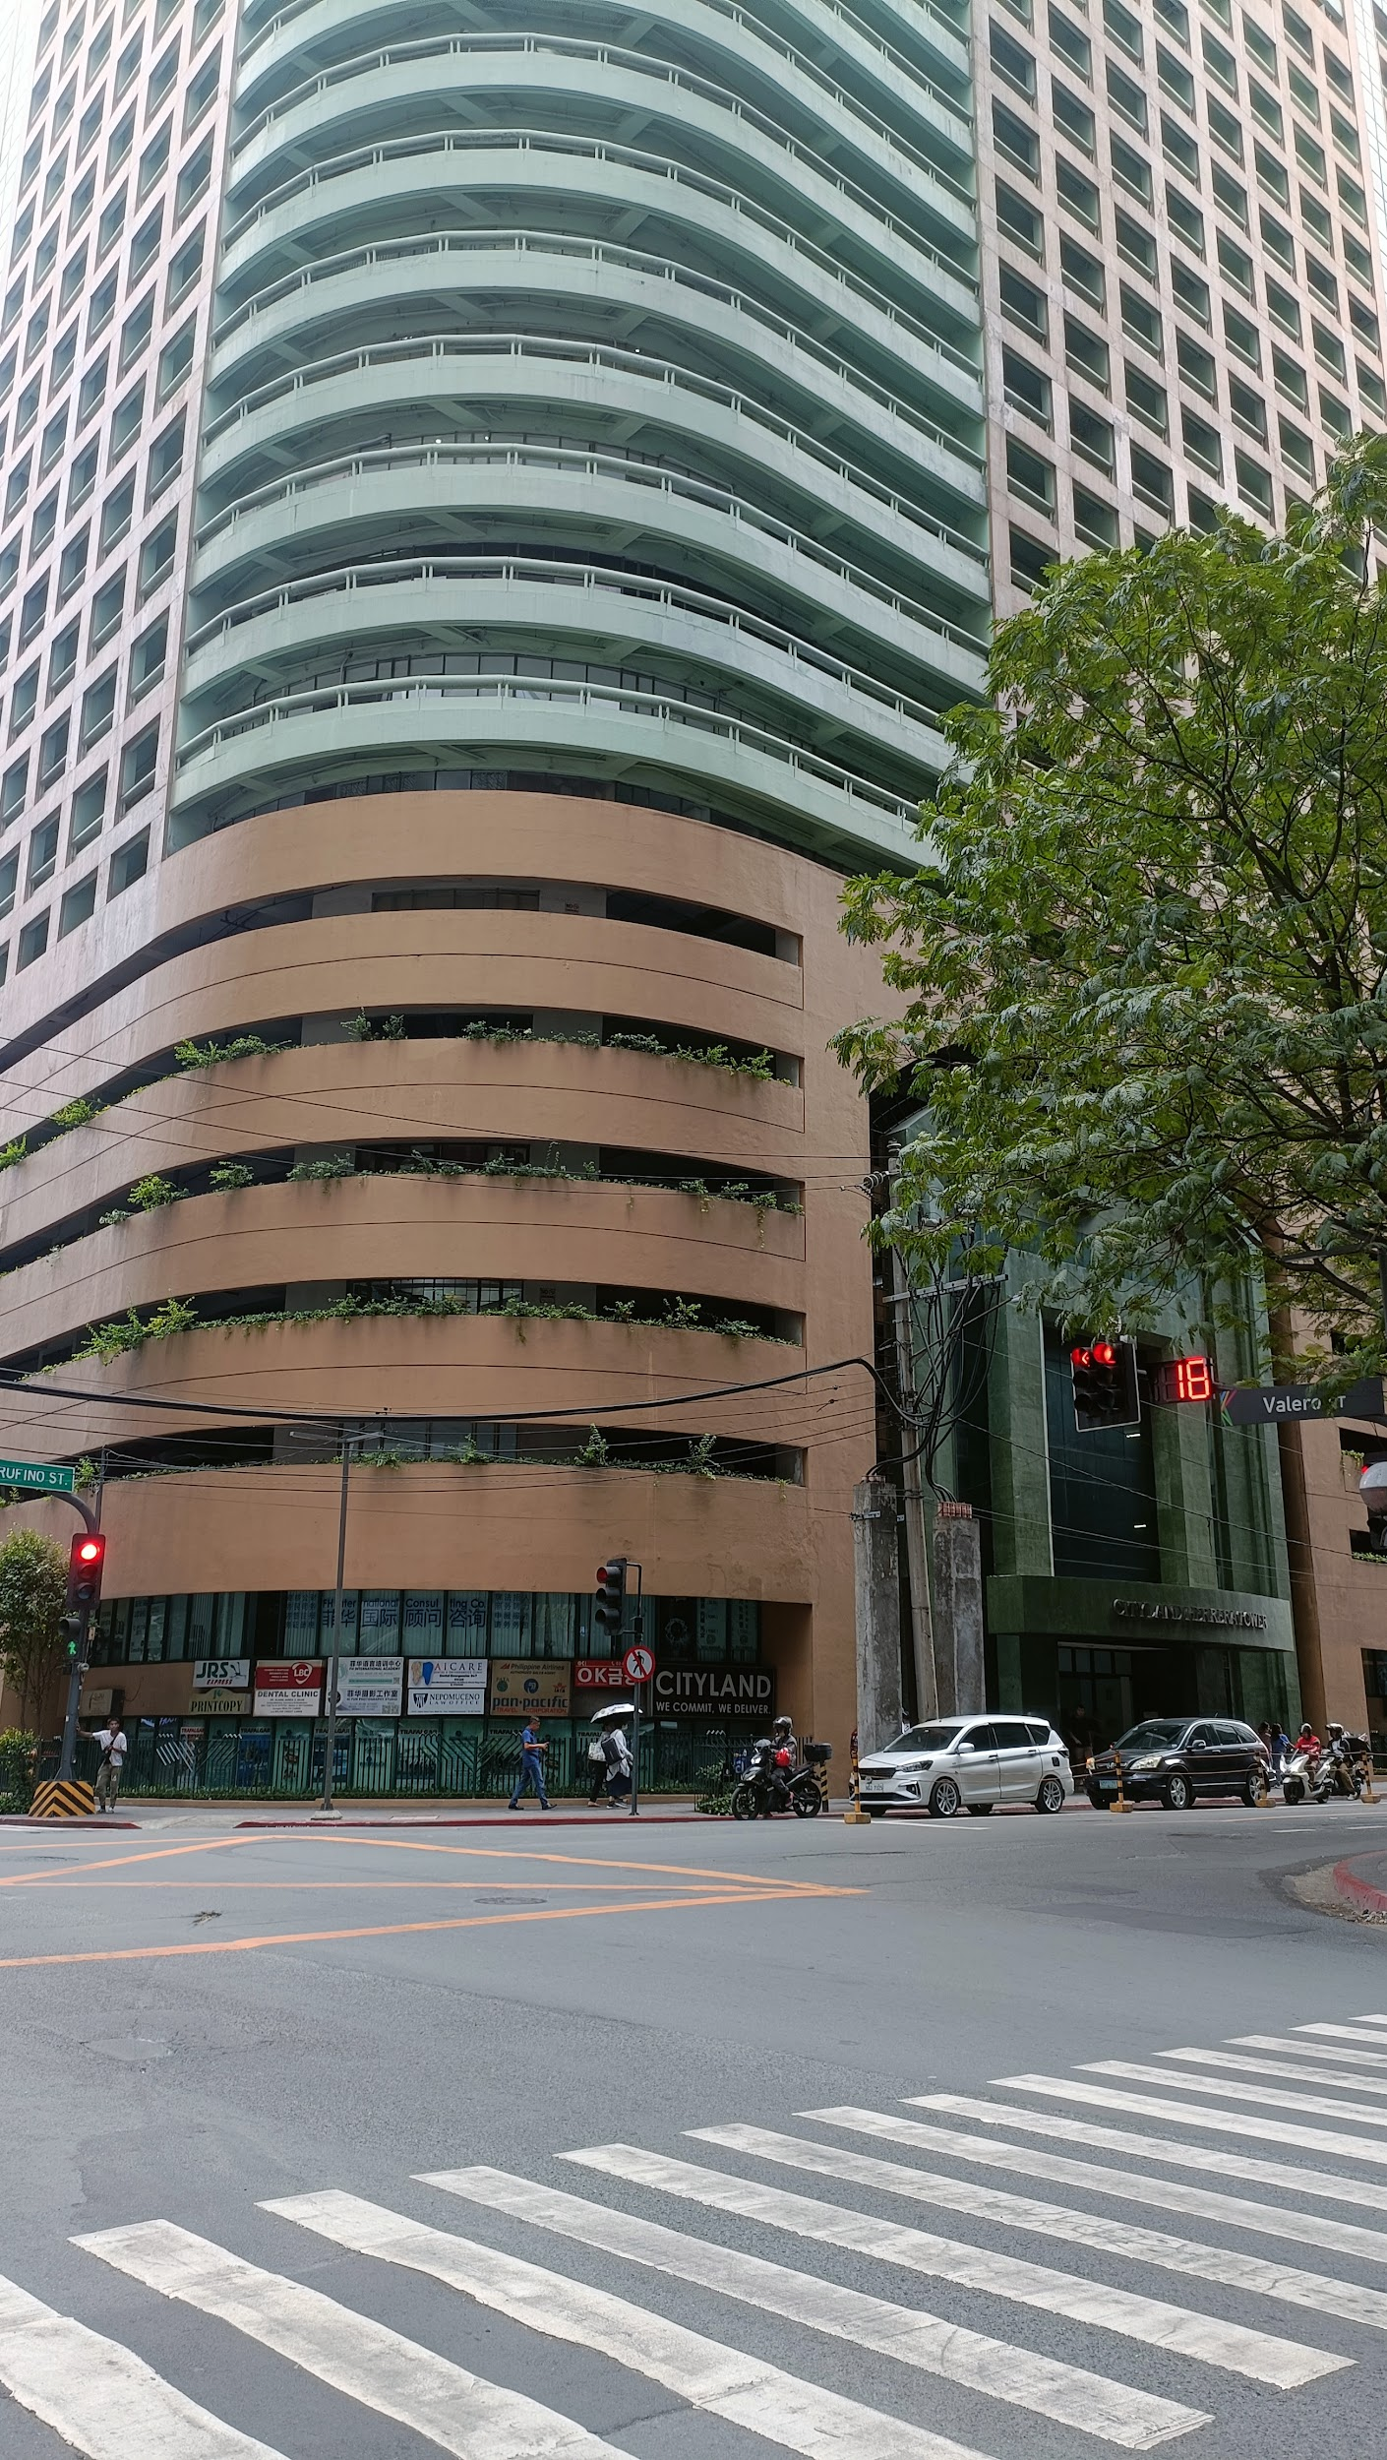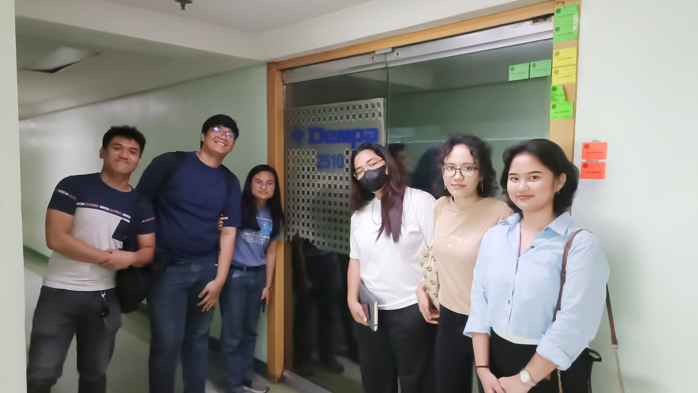

5.2 Visit to the Organization (DEMPA Publications Philippines Office)
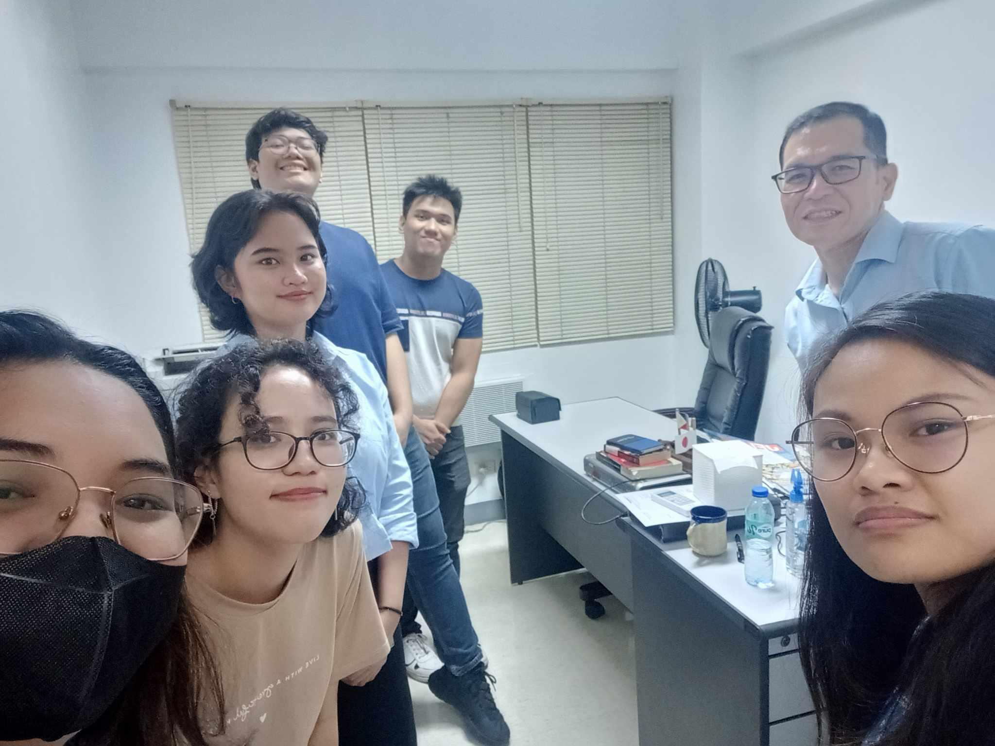

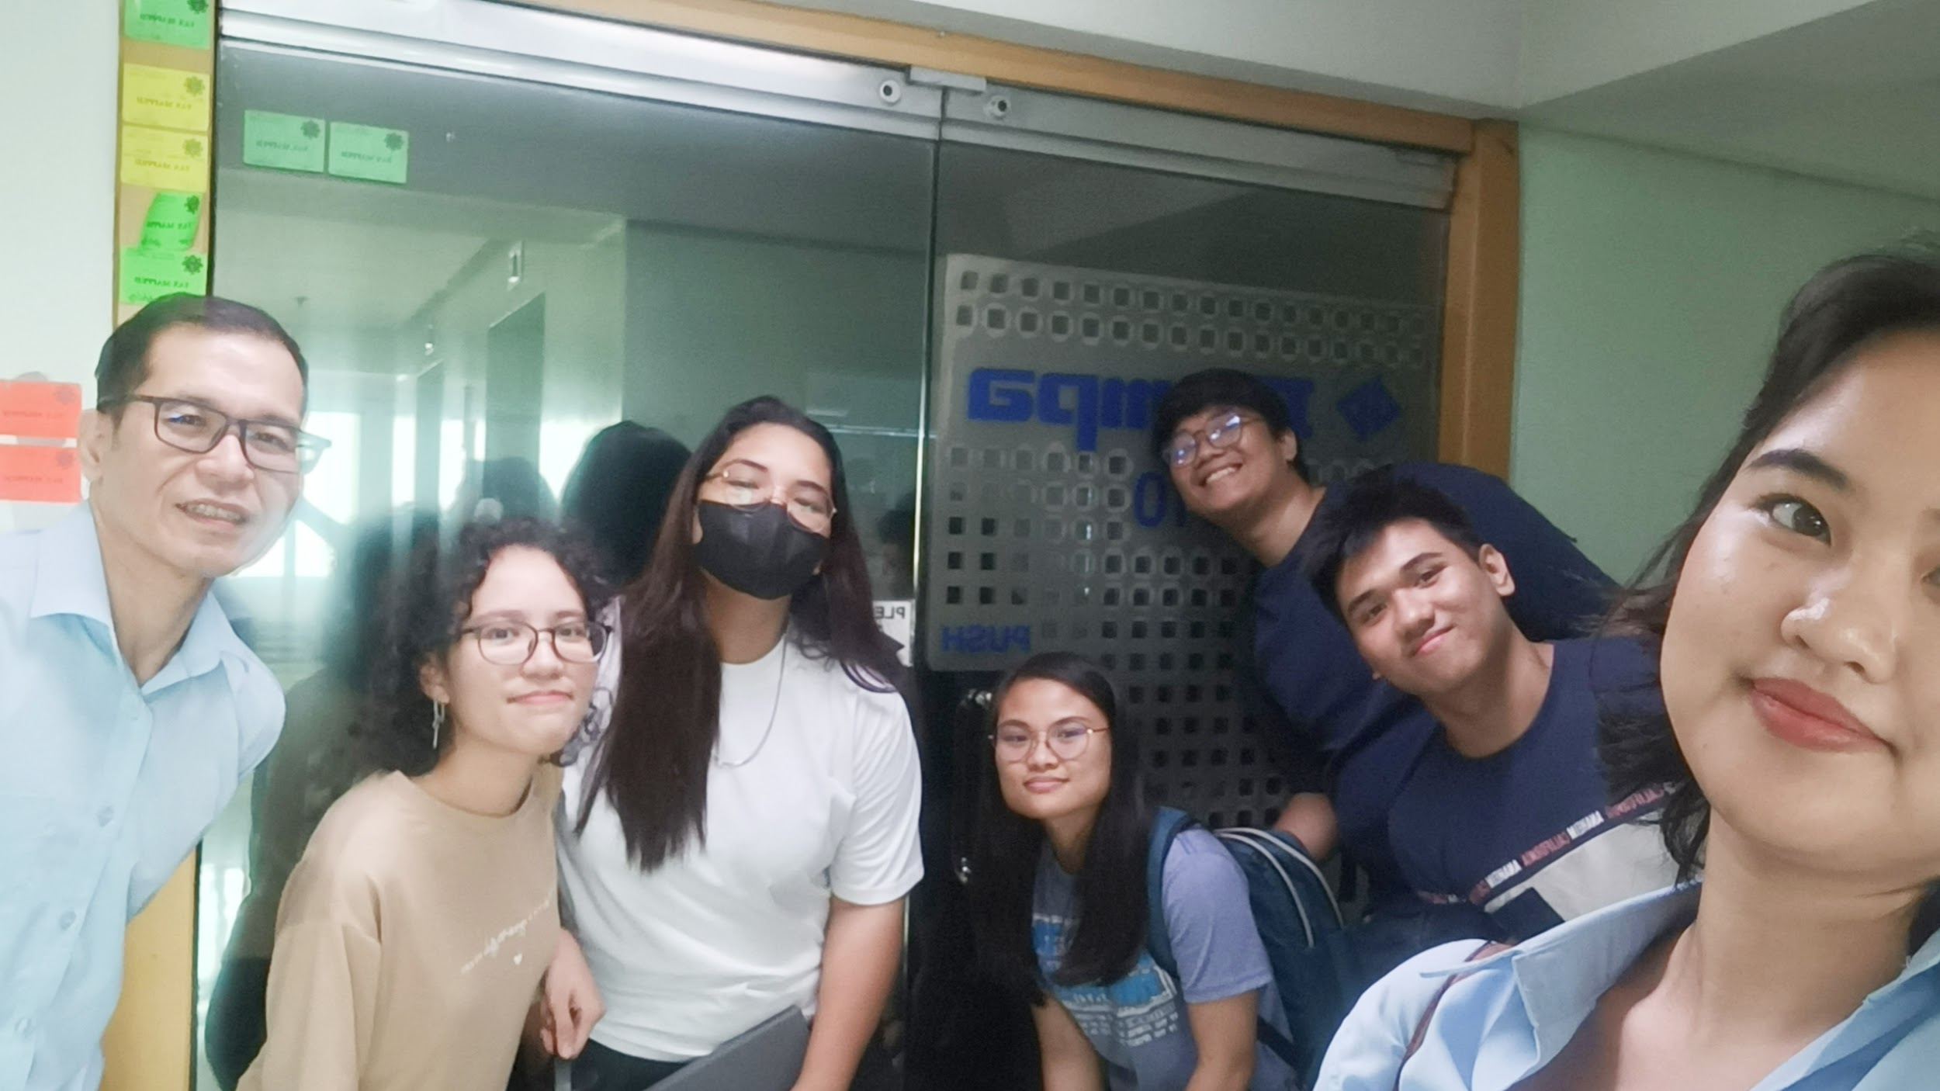

5.3 Program Development
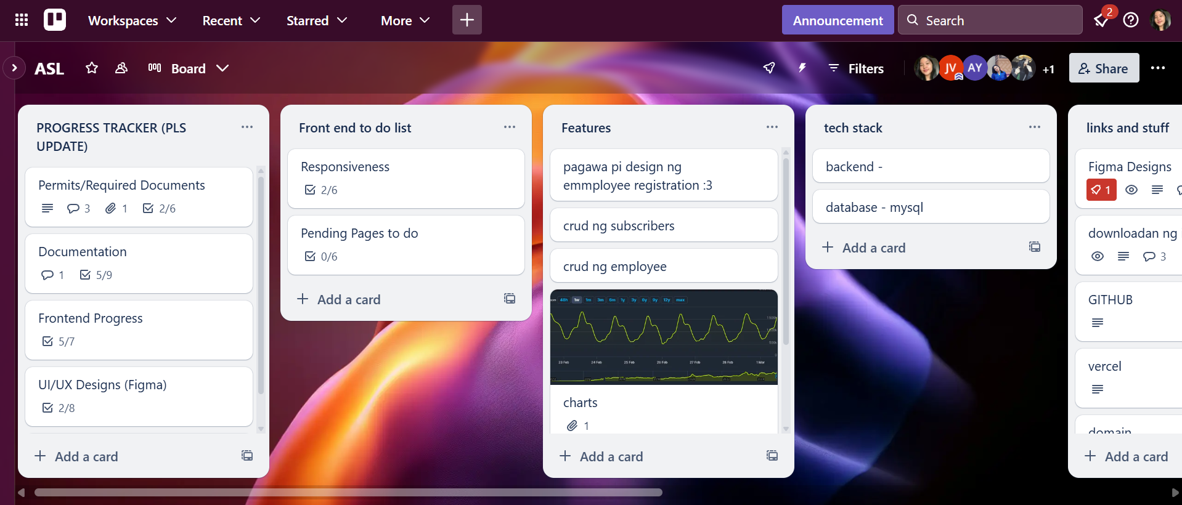

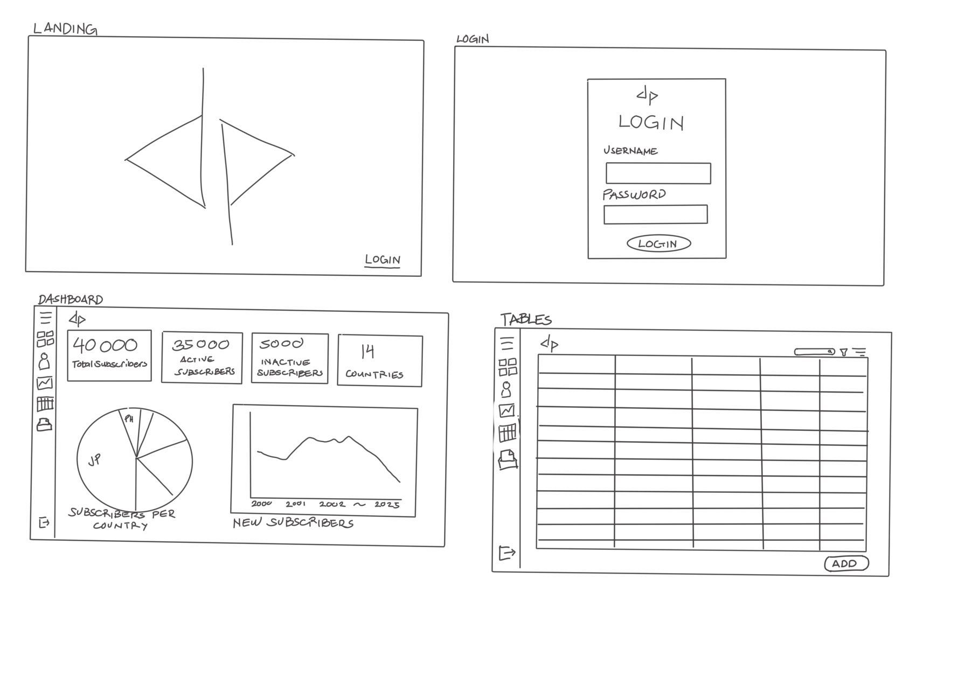

5.4 ASL Presentation
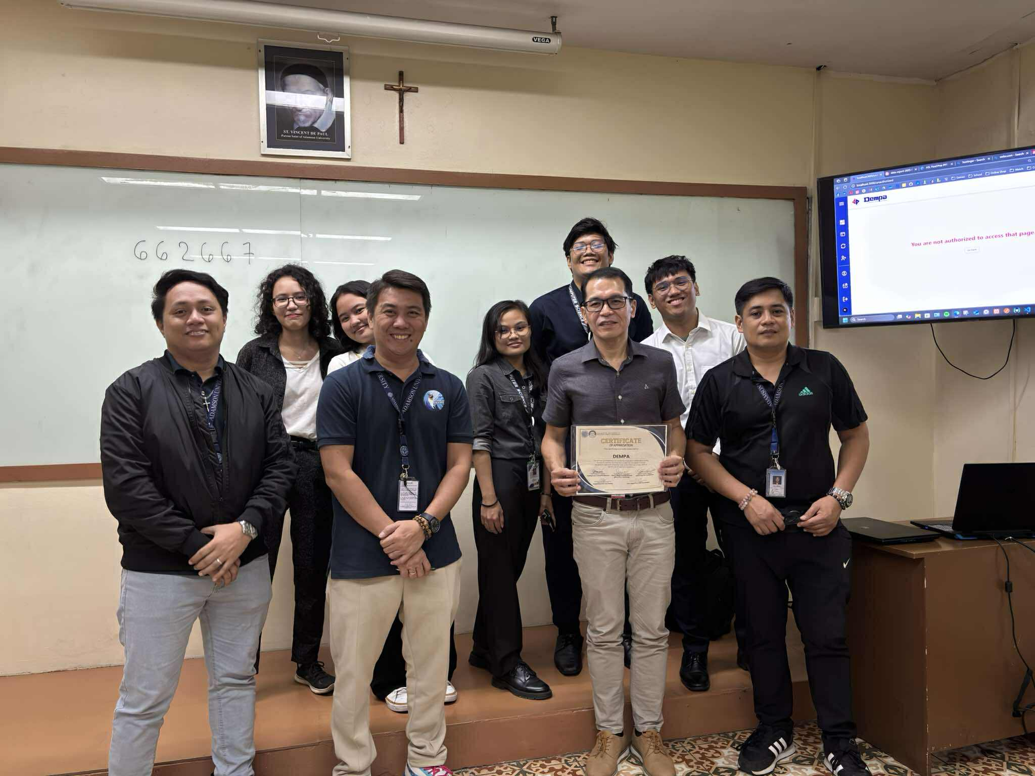
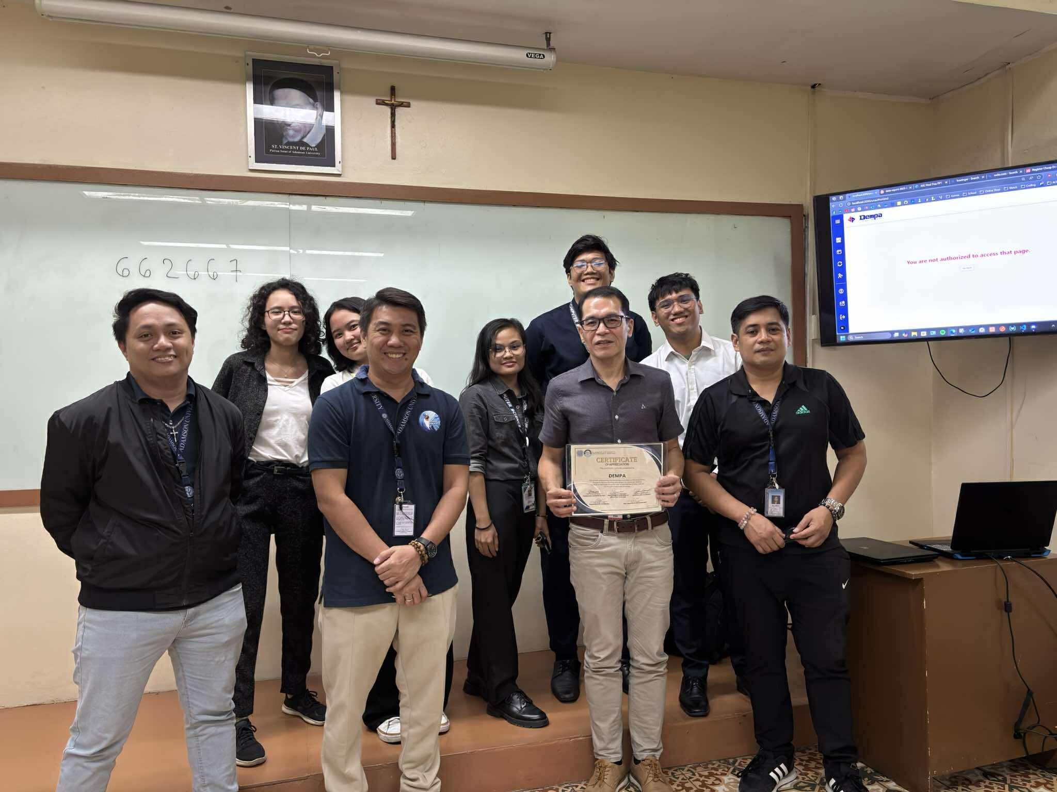

5.5 Deployment
